Individual Giving Officer

Role description
- Salary: £28,831 / Grade F
- Location: Bristol Hub (hybrid)
- Line manager: Supporter Engagement and Giving Manager
- Department / Team: Strategy and Engagagement / Fundraising and Supporter Engagement / Supporter Engagement and Giving team

Role summary

The Individual Giving Officer is a key role in the Supporter Engagement and Giving team responsible for delivering and developing fundraising appeals and campaigns across a range of products and channels. This position is essential in generating funds to help more people walk, wheel and cycle, and keep the National Cycle Network open for all.
The Supporter Engagement team consists of five people and sits within the wider Fundraising and Supporter Engagement directorate. Over the past two years, the department has seen significant income growth as it expands individual giving fundraising initiatives, channels and appeals. These efforts aim to raise awareness and generate unrestricted income to make active travel more accessible for everyone.
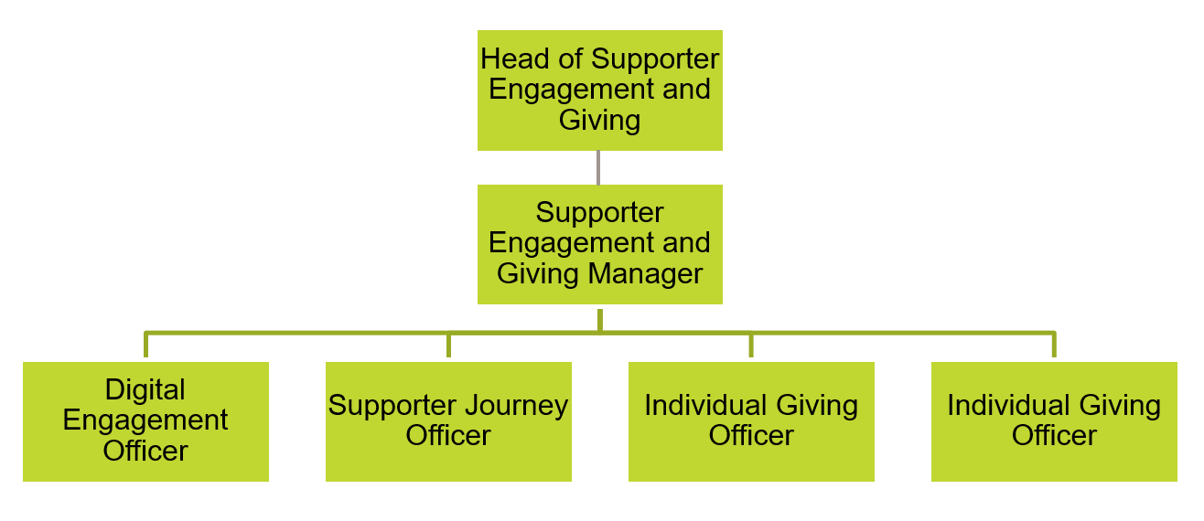
In Spring 2025, Sustrans will launch an ambitious new five-year strategy focusing on core areas of impact; enhancing the National Cycle Network, and funding projects that connect communities through active travel. As fundraising becomes more critical than ever, the Individual Giving Officer will play a vital role in delivering our most effective appeals to support this mission.

Key responsibilities

- Project manage fundraising campaigns working to agreed budgets, schedule, and KPIs. Including cash appeals, regular gift upgrade/reactivation/cash to committed appeals, and prize-led campaigns from beginning to end across a range of channels including email, post and telemarketing with support from the Supporter Engagement & Giving Manager.
- Devise and deliver supporter communications by email as required, including stewardship activity, welcome journey content, appeal communications and fundraising product marketing.
- Develop and maintain relationships with key internal teams and stakeholders, including communications officers, project staff, land managers, and content officers to enable content gathering which demonstrates the impact of Sustrans work for our donors.
- Working with colleagues within the Supporter Care team and Database and Insight team to report on campaigns, and keep the fundraising database up to date. Ensuring record keeping is accurate and efficient and contributes to delivering an outstanding donor experience.
- Supporting the Supporter Engagement and Giving Manager to implement new fundraising propositions through multiple channels (including telephone and digital) to maximise income.
- To liaise regularly with colleagues across Sustrans to increase and maintain a good understanding of Sustrans’ work and impact, and initiatives that could be used as exemplars of our work in supporter communications.
- To monitor compliance with fundraising regulation and data legislation.

We don’t expect anyone to be an expert in all these areas and as long as you meet the person specification we can train you in any gaps.

Person specification

Specific qualifications or experience required
- Some experience in project management within fundraising, marketing or campaign development.
- Some experience in producing and/or collating content for multiple channels including printed material, e-newsletters, social media.
- Experience of collaborating across different stakeholders to achieve positive results
- Some experience of working with external agencies, such as printers, creative agencies and telemarketing agencies would be helpful.

Specific/technical knowledge required
- Knowledge of fundraising principles and activities including donor engagement, recruitment and retention
- Knowledge of relevant fundraising legislation and best practice
- Knowledge of GDPR and Data Protection compliance

Skills and abilities
- Excellent interpersonal, networking and relationship building skills
- Excellent written and verbal communication skills.
- Good numeracy skills with the ability to analyse data
- Excellent time management; ability to successfully plan and manage varied workload and work independently with minimal supervision
- Excellent IT literacy, including MS Office and a good working knowledge of at least one fundraising CRM and one email marketing tool with good attention to detail

This document does not form part of the contract of employment but does outline our expectations. If we need to amend this document in the future we will consult with the post holder before doing so.
Sustrans is a registered charity in England and Wales (number 326550) and Scotland (SC039263).
We work for and with communities, helping them come to life by walking, wheeling and cycling.
We campaign to create healthier places and happier lives for everyone.
Join us on our journey. www.sustrans.org.uk

