Director, London
Candidate Information Pack

05 March 2020

Sustrans is the charity making it easier for people to walk and cycle.
We connect people and places, create liveable neighbourhoods, transform the school run and deliver a happier, healthier commute.
Join us on our journey.
www.sustrans.org.uk
Registered Charity No. 326550 (England and Wales) SC039263 (Scotland).
© Sustrans

Contents
1
Document title over one line, maximum 15 words text text text text text
00 Month 2019
Welcome note 2
About Sustrans 3
Our work 5
Our structure 6
Job description 7
Person specification 12
The benefits 15
How to apply 16

Welcome note
Matt Winfield - Executive Director, England
Thank you for your interest in the role of Director, London here at Sustrans.

We have a passionate and skilled team in London who will join you in support of our mission to make it easier for people to walk and cycle. We are at an exciting time of change in the capital where healthy streets and clean air are vital to the millions who live, work and play here. Sustrans will play a pivotal role, working with partners, to make London a happier healthier city for everyone.

We are looking for someone who can provide outstanding leadership and guidance to our teams. Someone who is values-driven and can through inclusive leadership, continue the development and delivery of our vision – a society where the way we travel creates healthier places and happier lives for everyone.

We need an individual who has a strong track record of leading delivery through multi-disciplinary teams, of setting strategic direction and working collaboratively with stakeholders. An individual who can act as an ambassador for Sustrans. In return this role offers the opportunity to join an amazing charity where you will see the impact of your work making a positive difference to society.

We offer flexible working practices across our workforce and our teams are friendly and supportive. We really listen and make time for innovation through our people-centred management culture. We are very proud of the result of our annual staff survey for 2019 which puts us in the top third of employers who measure Employee Net Promoter Score with our highest scoring question being “how much do you feel you are treated with respect at work?”.

This is a fantastic time to join Sustrans and we look forward to receiving your application.

Best Wishes
Matt

About Sustrans
Who we are

We are Sustrans. We are the charity that makes it easier for people to walk and cycle. We work with partners to deliver high quality people-centred schemes that transform places and communities to work better for everyone. We want London to be a happier, healthier city where the air is clean and people can make travel choices which are good for them, their neighbourhoods and the environment.

Across the UK we have over 600 staff (approximately 80 in the London team) and over 3,200 volunteers who are rooted in the communities where we work. We are the founder and custodian of the National Cycle Network, a network of signed paths and routes for walking, cycling and exploring outdoors. The Network spans the UK, connecting people and places and providing traffic free spaces for everyone to enjoy.

As a practical, impact led charity, Sustrans works in partnership, bringing people together to find the right solutions. We make the case for walking and cycling by using robust evidence and showing what can be done. We are grounded in communities and believe that grassroots support combined with political leadership drives real change, fast.

Over the next five years our priority will be working with others to revitalise the National Cycle Network and make our cities and towns more liveable for everyone.

Add caption and credit if possible

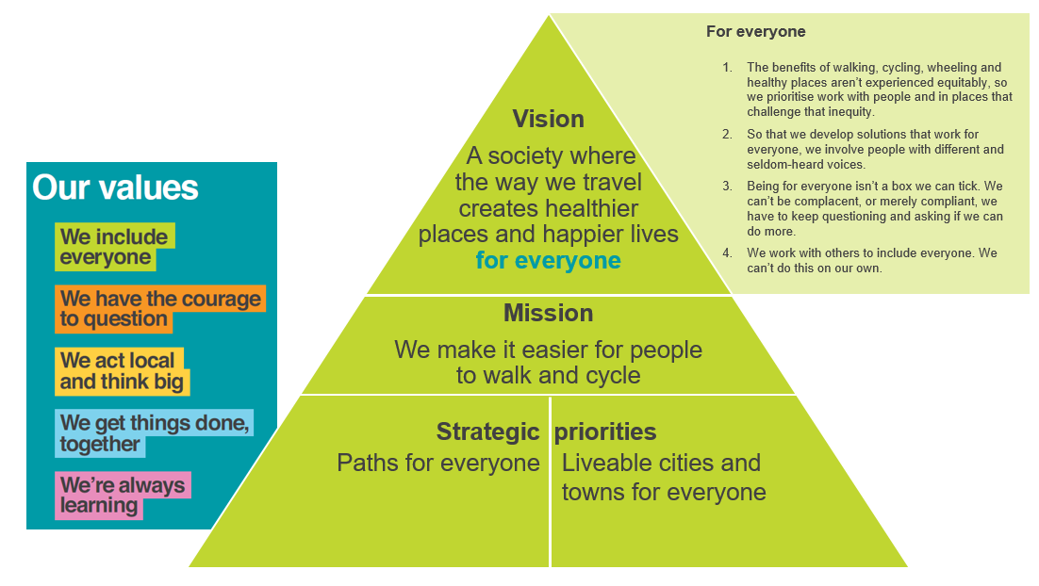
Our five year strategy

How we work

- We make the case for walking and cycling by using robust evidence and showing what can be done.
- We provide solutions. We capture imaginations with bold ideas that we can help make happen.
- We’re grounded in communities, involving local people in the design, delivery and maintenance of solutions.
Our work
London
In London our talented and committed team deliver a range of competitive high-quality community centred schemes, transforming places and linear spaces, one neighbourhood at a time. We have deep and evolving experience of creating urban places that work better for people and make it easier for everyone to walk and cycle.
We also deliver a range of behaviour change projects in schools, communities and workplaces across London, including our School Streets programme. We are also Transport for London’s delivery agent for their inspirational borough-wide Healthy Streets Programme.
These projects are mainly funded by successful bids to a range of funders including Transport for London, London’s boroughs and other stakeholders.
Sustrans adds value to every project it supports, through the meaningful partnerships forged with local authorities and community groups, and as an independent charity stakeholder with expertise in community engagement, behaviour change and design.
More information can be found here:
https://www.sustrans.org.uk/about-us/

https://www.sustrans.org.uk/our-blog/news/2019/january/our-work-in-london-2019-streets-ahead/

https://www.sustrans.org.uk/our-blog/news/2019/august/sustrans-to-provide-support-for-new-tfl-programme/

https://www.sustrans.org.uk/our-blog/news/2019/september/delivering-school-streets-and-cleaning-up-air-quality-in-tower-hamlets/

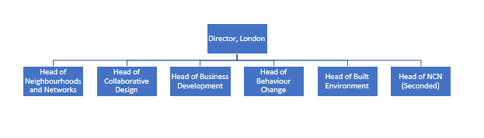
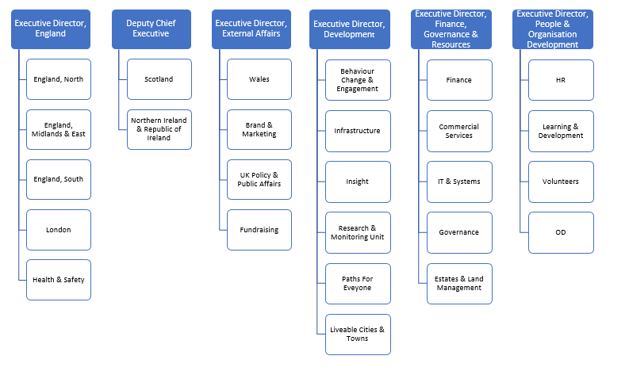
Our Structure
London Structure
Charity Structure
Job description
Job title: Director, London

Reference: SUS2841
Salary: £56,559 plus a London Weighting allowance of £3,995 pa
Hours: 37.5 per week
Base: Sustrans London Office
Job Purpose
Accountable to the Executive Director, England for the overall strategic direction of Sustrans in London. This includes managing staff and resources and providing leadership to the heads of teams in order to deliver Sustrans’ strategy and business plan priorities and initiatives across London.

Strengthening strategic relationships with key organisations and politicians in London and influencing decision-makers in this field. Building relationships with partners/funding bodies in order to secure funds for project delivery and implementation and to help catalyse change in London. Responsible for leadership of income generation through business development.

Contributing to Sustrans-wide strategic development as a member of Sustrans’ team of directors.
Place in organisational structure
The postholder will report to the Executive Director, England.
Key Relationships:
Internal: Chief Executive
Executive Director, England
Sustrans Executive team
Other Sustrans Directors
Sustrans staff in London, particularly the Senior Leadership Team
Head of Digital and Marketing
Sustrans Board of Trustees
Health and Safety team
HR team
Finance team
Sustrans volunteers

External: Greater London Authority, including the London Assembly and the Mayor’s Office
Sustrans’ London Advisory Group
Transport for London
Senior Officers & members at London Boroughs
Funding agencies
Community and voluntary organisations working for a liveable city
Selected consultants
Local, regional and national media
Key Responsibilities

Strategic governance
- To lead on the strategic priorities and initiatives for London through ownership of the London Business Plan.
- To be responsible for maximising the impact of Sustrans’ operations in London.
- To be responsible for financial performance of Sustrans’ operations in London.
- To be responsible for quarterly reporting to the Executive Director, England using agreed templates and indicators.
- To ensure, through delegated responsibility, successful management of project delivery, budget management and compliance with all relevant project management systems and processes.
- To facilitate the Sustrans London Advisory Group, maximising its networking and influencing benefits.
- Attendance at staff forum.
- Ensure that Sustrans in London is radical, sustainable and impactful.
Influencing and external affairs
- To establish strong relationships with major organisations, local authorities and key stakeholders in London to ensure that Liveable Cities and Paths for Everyone, and the work that Sustrans delivers, are recognised and supported.
- To build on existing, and seek new, political and financial support for relevant initiatives.
- To respond to relevant consultations and provide strategic inputs to key policy debates and formulation.
- To network with other organisations working in the transport, urban planning and environment fields and develop joint working, liaison and co-operation on key policy issues and areas of common interest.
Business development
- To be responsible for leadership of income generation through business development in London.
- To be responsible for relationships with London based partners/funding bodies and to build and develop these relationships.
- To contribute toward the development of new ideas and innovative strategies for product development, marketing, branding, or business opportunities.
People management
- To line manage London-based staff in the course of their work and to maintain a positive work ethic and sense of ‘team’.
- To manage, develop and coach team members by setting clear objectives and monitoring performance to maximise their potential.
- To work with HR to ensure that training and development of staff is planned effectively and in line with business need.
Communication and marketing
- To raise the profile and reputation of Sustrans in London by acting as a media spokesperson and building relationships with journalists in order to promote our policies and highlight key demonstration projects.
- To support and comply with the charity’s guidance on branding, tone of voice and key messages, positively contributing towards raising Sustrans’ profile.
Training and personal development
- Attend essential Sustrans training as required by the Charity.
- Ensure own personal development by working to objectives set as part of the Charity’s appraisal process.
Health & safety, safeguarding and equality, diversity and inclusion
- To support and comply with the organisation’s policy for the management of Health and Safety.
- To support and comply with the organisation’s policies for the management of safeguarding.
- To work in a manner that supports and complies with Sustrans Children, Young People & Vulnerable Adult Protection and Data Protection policies.
- To support and comply with the organisation’s policy and procedures relating to Equality, Diversity and Inclusion and apply principles of best practice in own role and ensure others in London senior management are also compliant.

Sustrans-wide
- From time to time, to lead Sustrans-wide projects.
- This role may have additional responsibilities as a member of a network of colleagues working on Sustrans-wide oversight of strategic communications.
Other
- To keep the charity’s relevant business management systems e.g. CRM, focal point, business management template up to date.
- To perform any other duties consistent with the nature and grade of the role as agreed with the line manager.
Working conditions

The postholder will be based in Sustrans office in London and will be expected to be flexible in the way hours are worked. Extensive and regular travel around London and visits to the organisation’s other offices throughout the UK will be expected.

This job description does not form part of the contract of employment but indicates how that contract should be performed. The job description may be subject to amendment in the light of experience and in consultation with the post holder.

Compiled by: Executive Director, England
Date: March 2020
Person specification
Essential Qualifications, Education and Training
- Qualified to degree level or equivalent, with evidence of continuing professional development.
Essential Experience
- Well-developed leadership and management skills with experience of motivating and developing staff and building high performing teams.
- Broad significant experience of working with TfL and local government in London in sustainable transport, urban development or associated industry.
- Track record of managing the strategic and operational responsibilities in the following areas:
  - Strategic planning
  - Business planning and evaluation
  - Impact evaluation
  - Finance and budget management
  - Development and delivery of projects
  - Strategic stakeholder management (including politicians, partners and funding bodies)
  - Policy development
  - Governance
- Providing effective business leadership, advice and support to the Executive Director, England.
- Ensuring alignment to our charitable objectives.
- Experience of media relations.
Essential Skills and Abilities
- Ability to set strategic direction in a way that inspires confidence, commitment and encourages ideas and innovation from your teams.
- A talent for conducting impactful conversations, asking effective questions and influencing people at all levels of the organisation and your stakeholders.
- Can make sound, well considered decisions and judgments.
- Strong in effectively delegating and managing the performance of your teams.
- Excellent all-round communicator, adept at:
  - Presenting
  - Being an effective and passionate spokesperson for Sustrans
  - Excellent negotiations skills
  - Confident and able to chair complex meetings.
- Ability to identify and realise opportunities to increase Sustrans impact.
Essential Knowledge
- Understands relevant organisations and political structures in London.
- A good understanding of tender and bid processes.
- Flair for preparing and pitching compelling business cases to potential clients, funders and/or partners.
Other
- Committed to the promotion of sustainable transport, demonstrating and personally representing Sustrans values and vision throughout your work.
Desirable Experience
- Experience in transport planning and policy work.
- Voluntary sector experience.
Desirable Skills and Abilities
- Business development skills.
Desirable Knowledge
- Knowledge of relevant organisations and political structures.

The benefits
Salary £56,559 per annum plus London Weighting £3,995 pa

As well as working for a charity with such a strong core mission and vision, you will find we have a great working culture. We also offer many other work-related benefits:

- Flexible Working practices (full time hours are 37.5 per week, Monday - Friday)
- 26 days leave per annum plus bank holidays for full-time working
- Ability to buy an extra week of annual leave (pro-rata for part-time staff)
- Group Personal Pension scheme with a 4% or 5% of basic salary contribution being matched by Sustrans
- Continued professional development
- Enhanced maternity and paternity pay
- Staff volunteer days
- 24/7 free, impartial and confidential support service
- Bike, computer and season ticket loan
- Discount benefits
- We are members of the Green Commute Initiative and CycleScheme who both offer cycle to work schemes

How to apply
We are using a quick apply process for this role. The link can be found on the bottom of the advert on our website. You will need to upload your CV and a personal statement. The personal statement should demonstrate your skills and relevant experience against the criteria in the personal specification.
Timeline
Closing date 9am on Tuesday, 7 April 2020
Interview with Sustrans week commencing 27 April 2020
We understand it’s difficult to think about applying for jobs and attending interviews at the moment. We will review how we approach the interview process closer to the time and will aim to be as flexible as possible.

