England Director, Midlands & East
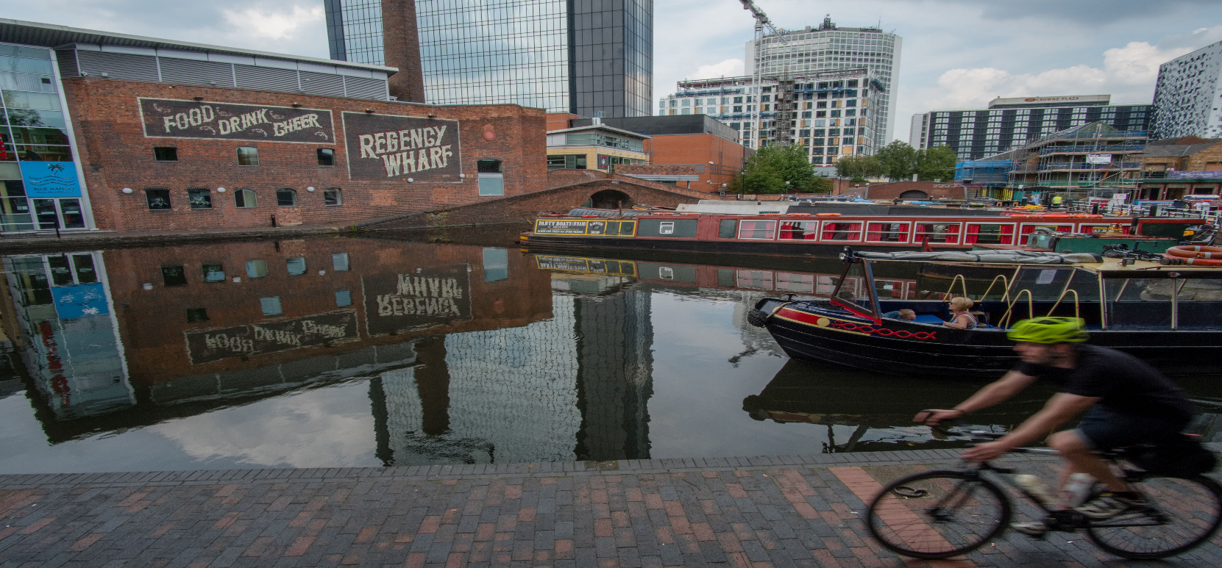
Candidate Information Pack

05 March 2020

Sustrans is the charity making it easier for people to walk and cycle.
We connect people and places, create liveable neighbourhoods, transform the school run and deliver a happier, healthier commute.
Join us on our journey.
© Sustrans

www.sustrans.org.uk
Registered Charity No. 326550 (England and Wales) SC039263 (Scotland).
Contents
1
Document title over one line, maximum 15 words text text text text text
00 Month 2019
Welcome note 1
About Sustrans 1
Our work 1
Our structure 1
Job description 1
Person specification 1
The benefits 1
How to apply 1

Welcome note
Matt Winfield - Executive Director, England
Thank you for your interest in the role of England Director, Midlands and East here at Sustrans.

We have a passionate and skilled team working in support of our mission to make it easier for people to walk and cycle. We are at an exciting time of change across England where healthy streets and clean air are vital to the millions who live, work and play here. Sustrans continues to play a pivotal role, working alongside our partners, to make cities and towns across the Midlands and East healthier for everyone.

We are looking for someone who can provide outstanding leadership and guidance to our teams. Someone who is values-driven, and can through inclusive leadership, continue the development and delivery of our vision – a society where the way we travel creates healthier places and happier lives for everyone.

We need an individual who has a strong track record of leading delivery through multi-disciplinary teams, of setting strategic direction, of thriving in a role where priorities change and no two days are the same and where working collaboratively with stakeholders brings real results to be proud of. An individual who can act as an ambassador for Sustrans right across the region and be a key senior leader within our organisation. In return this role offers the opportunity to join an amazing charity where you will see the impact of your work making a positive difference to individuals and to society.

We offer flexible working practices across our workforce and our teams are friendly and supportive. We really listen and make time for innovation through our people-centred management culture. We are very proud of the result of our annual staff survey for 2019 which puts us in the top third of employers who measure Employee Net Promoter Score, demonstrating that people enjoy working for Sustrans and would recommend doing so to others.

This is a fantastic time to join Sustrans and we look forward to receiving your application.

Best Wishes

Matt

About Sustrans
Who we are

We are Sustrans. We are the charity that makes it easier for people to walk and cycle. We work with partners to deliver high quality people-centred schemes that transform places and communities to work better for everyone.

Across the UK we have over 600 staff (50 + in the Midlands and East team) and over 3,200 volunteers who are rooted in the communities where we work. We are the founder and custodian of the National Cycle Network, a network of signed paths and routes for walking, cycling and exploring outdoors. The Network spans the UK, connecting people and places and providing traffic free spaces for everyone to enjoy.

As a practical, impact led charity, Sustrans works in partnership, bringing people together to find the right solutions. We make the case for walking and cycling by using robust evidence and showing what can be done. We are grounded in communities and believe that grassroots support combined with political leadership drives real change, fast.

Over the next five years our priority will be working with others to revitalise the National Cycle Network through our Paths for Everyone strategic priority and making our cities and towns more liveable for everyone.

Our five year strategy
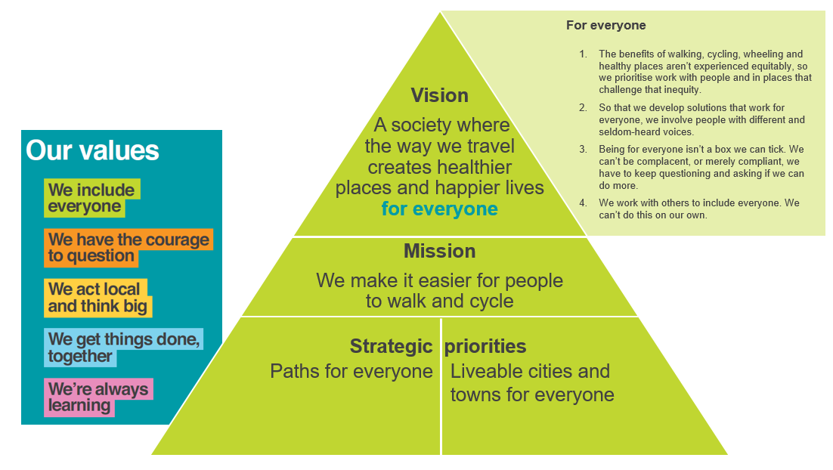

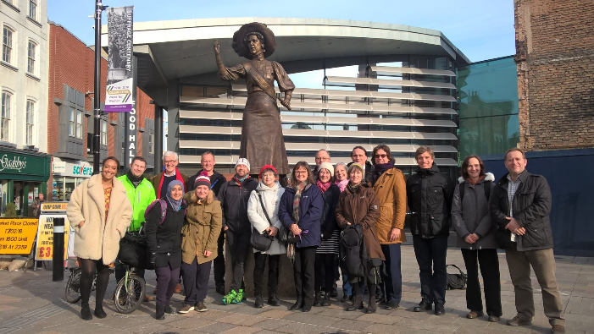
Our work
Midlands and East
In the Midlands and East our talented, creative and committed team deliver a range of competitive, high-quality community centred schemes, transforming places and linear spaces in ways that enable more people to choose to cycle and walk for more of their journeys.
Our work is currently split between four departments.
- Network Development - focuses on the improvement of the National Cycle Network
- Design and Engineering - helping our partners design and build the best possible infrastructure in a way that engages communities
- Delivery - working through a team of engagement officers to support more people of all ages to cycle and walk
- Partnerships - influencing partners, engaging with stakeholders and overseeing business development opportunities
We have deep, current and evolving experience of creating urban places and improving the National Cycle Network through working effectively with a wide range of partners and successfully attracting funding. In 2020/21 we are overseeing and delivering a range of Department for Transport funded National Cycle Network projects in partnership with Local Authorities across the Midlands and East of England.
We also deliver a range of behaviour change projects in schools, communities and workplaces across the Midlands and East. For example we have schools officers in Peterborough, Leicester, Luton, Bedford and Hereford, run a community co-design project with older people in Tyburn, Birmingham and have officers liaising with the community on key housing sites in Nottinghamshire and Essex.
Our work is currently funded through the strong relationships we have nationally and regionally with the Department for Transport, Combined Authorities, Highways England and Local Authorities. We also have an excellent track record in competitively winning tenders and securing grant funding.
More information can be found here:

https://www.sustrans.org.uk/our-blog/projects/2019/england/age-friendly-tyburn/
https://www.sustrans.org.uk/bike-life/bike-life-west-midlands/
https://www.sustrans.org.uk/our-blog/opinion/2019/april/helping-jobseekers-get-on-their-bikes-in-nottingham-and-derby/
https://www.sustrans.org.uk/our-blog/projects/2019/uk-wide/sustrans-big-pedal/

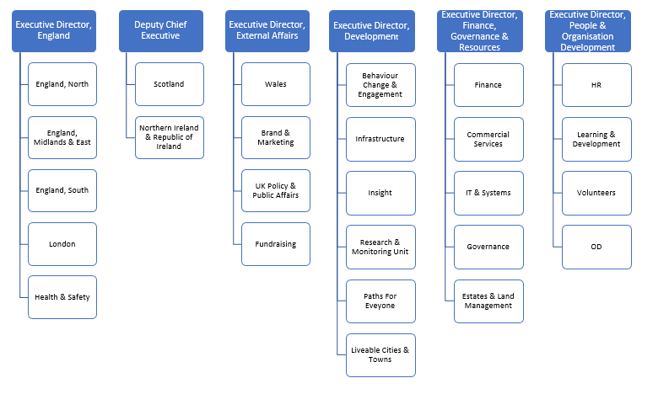
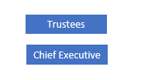
Our Structure
Charity Structure

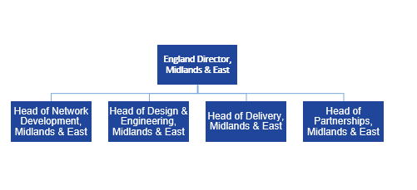
Midlands and East Structure

Job description
Job title: England Director, Midlands & East

Reference: SUS2889
Salary: £56,559
Hours: 37.5 hours per week
Base: Negotiable (we have offices in Nottingham, Birmingham & Peterborough)
Job Purpose
To be accountable to the Executive Director, England for the overall strategic direction of Sustrans in England Midlands & East, including managing staff and resources to deliver Sustrans’ strategy and business plan priorities, and England-wide priorities and initiatives.

To be responsible for the operational management of all teams in England Midlands & East, providing leadership to department heads, inspiring them and the wider team. To strengthen strategic relationships with the key organisations and politicians in England Midlands & East and influence decision-makers across a range of portfolios. To build relationships with partners/funding bodies and be responsible for leadership of income generation through business development.

To provide leadership, management and motivation to staff in England Midlands & East. To contribute to Sustrans-wide strategic development as a member Sustrans’ team of directors.
Place in organisational structure
The postholder will report to the Executive Director, England.
Key Relationships:

Internal: Executive Director, England
Head of Delivery, England Midlands & East
Head of Network Development, England Midlands & East
Head of Partnerships, England Midlands & East
Head of Design & Engineering, England Midlands & East

England Director, South

England Director, North
Sustrans Executive team
Other Sustrans Directors
Support Office, England Midlands & East
Administration Officer, England Midlands & East
HR team
Finance team
Volunteers

External: Key local authority partners; members and officers
Combined Authorities – mayors and officers
Public Health bodies
Members of Parliament
Local Enterprise Partnerships
Existing and prospective funders
Local partner organisations
Media
Key Responsibilities

Leadership and governance
- To work with the Executive Director, England to design structures and plan resources needed in England Midlands & East.
- To be responsible for financial management of the business in England Midlands & East, through ensuring successful budget management of project delivery and compliance with all relevant systems and processes.
- To ensure budgets are prepared which are managed effectively, reflect Sustrans’ strategy, the availability of funding and which move the region towards a position where it is self-financing.
- To ensure, through delegated responsibility, successful management of project delivery, budget management and compliance with all relevant project management systems and processes
- To champion innovation across all areas of service delivery, encouraging teams to develop new offers in collaboration with the business development team.
- To work with the RPL CEO/Head of Estates to plan for the effective resourcing and delivery of Sustrans’ estate management.
- To ensure robust analysis and clear presentation of the impact and outcomes of Sustrans’ work in England Midlands & East.
Influencing and external affairs
- To lead influencing activity in England Midlands & East, by developing a detailed stakeholder engagement plan linked to the business plan influencing priorities, in discussion with relevant colleagues.
- To lead on the development of relationships with key decision makers identified in the stakeholder engagement plan / local authority senior staff and cabinet members, MPs and business leaders.
- To lead on the development of relationships with other organisations working in sectors relevant to Sustrans’ vision and to monitor progress in delivering all funded work streams to ensure successful delivery.
People management
- To inspire and lead the team heads in England Midlands & East, providing clear direction and empowering the team to be responsible for the development and successful delivery of project work and local influencing.
- To support and empower staff in the course of their work, and to maintain a positive work ethic and sense of ‘team’.
Communication and marketing
- To raise the profile and reputation of Sustrans by acting as a media spokesperson and building relationships with journalists in order to promote active travel and highlight Sustrans’ solutions across a range of policy areas
- To support and comply with the charity’s guidance on branding, tone of voice and key messages, positively contributing towards raising Sustrans’ profile.

Training and personal development
- To attend essential Sustrans training as required by the Charity.
- To ensure own personal development by working to objectives set as part of the Charity’s appraisal process.
Health & safety, safeguarding and equality, diversity and inclusion
- To support and comply with the organisation’s policy for the management of Health and Safety
- To support and comply with the organisation’s policies for the management of safeguarding
- To work in a manner that supports and complies with Sustrans Children, Young People & Vulnerable Adult Protection and Data Protection policies.
- To support and comply with the organisation’s policy and procedures relating to Equality, Diversity and Inclusion and apply principles of best practice in own role and ensure others in the South of England senior management team are also compliant.
Networks
- This role may have additional responsibilities as a member of a network of colleagues working on Sustrans-wide oversight of strategic communications.
Other
- To keep the charity’s Customer Relationship Management (CRM) and other internal information management systems up to date.
- To perform any other duties consistent with the nature and grade of the role as agreed with the line manager.

Working conditions

The postholder will be based in a Sustrans office in the Midlands & East and will be expected to be flexible in the ways hours are worked. Extensive and regular travel around the Midlands & East and visits to the organisation’s other offices throughout the UK will be expected. The postholder will also be expected to look for ways to save time and money whilst still meeting objectives through the effective use of communications technology.

This job description does not form part of the contract of employment but indicates how that contract should be performed. The job description may be subject to amendment in the light of experience and in consultation with the post holder.

Compiled by: Executive Director, England
Date: March 2020
Person specification
Essential Qualifications, Education and Training
- Qualified to degree level or equivalent, with evidence of continuing professional development.
Essential Experience
- Well-developed leadership and management skills with experience of motivating and developing staff and building high performing teams.
- Broad significant experience of working with combined authorities and local government in England regarding sustainable transport or urban development.
- Track record of managing the strategic and operational responsibilities in the following areas:
  - Strategic planning
  - Business planning and evaluation
  - Impact evaluation
  - Finance and budget management
  - Development and delivery of projects
  - Resource planning
  - Strategic stakeholder management (including politicians, partners and funding bodies)
  - Policy development
  - Governance
- Experience of overseeing funding proposals and negotiations.
- Experience of media relations.
Essential Skills and Abilities
- Ability to set strategic direction in a way that inspires confidence, commitment and encourages ideas and innovation from your teams.
- A talent for conducting impactful conversations, asking effective questions and influencing people at all levels of the organisation and your stakeholders.
- Can make sound, well considered decisions and judgments.
- Effective at delegating and managing the performance of your teams.
- Excellent all-round communicator, adept at:
  - Presenting
  - Being an effective and passionate spokesperson for Sustrans
  - Excellent negotiations skills
  - Confident and able to chair and facilitate complex meetings.
- Ability to identify and realise opportunities to increase and assess performance and impact.
Essential Knowledge
- Understands relevant organisations and political structures in the Midlands and East.
- A good understanding of tender and bid processes.
- Flair for preparing and pitching compelling business cases to potential clients, funders and/or partners.
- Knowledge of the benefits of sustainable transport and how to describe them.
- A sound understanding of current best practice regarding the design of cycling infrastructure in a variety of settings.
Other
- Committed to the promotion of sustainable transport, demonstrating and personally representing Sustrans values and vision throughout your work.
Desirable Experience
- Experience in transport planning and policy work.
- Voluntary sector management experience ideally to director level.
Desirable Skills and Abilities
- Business development skills.
Desirable Knowledge
- Knowledge of key organisations and individuals working in sustainable transport in the Midlands and East.

The benefits
Salary £56,559 per annum

As well as working for a charity with such a strong core mission and vision, you will find we have a great working culture. We also offer many other work-related benefits:

- Flexible Working practices (full time hours are 37.5 per week, Monday - Friday)
- 26 days leave per annum plus bank holidays for full-time working
- Ability to buy an extra week of annual leave (pro-rata for part-time staff)
- Group Personal Pension scheme with a 4% or 5% of basic salary contribution being matched by Sustrans
- Continued professional development
- Enhanced maternity and paternity pay
- Staff volunteer days
- 24/7 free, impartial and confidential support service
- Bike, computer and season ticket loan
- Discount benefits
- We are members of the Green Commute Initiative and CycleScheme who both offer cycle to work schemes

How to apply
We are using a quick apply process for this role. The link can be found on the bottom of the advert on our website. You will need to upload your CV and a personal statement. The personal statement should demonstrate your skills and relevant experience against the criteria in the personal specification.

Timeline
Closing date 9am on Monday, 6 April 2020
Interview with Sustrans week commencing 20 April 2020
We understand it’s difficult to think about applying for jobs and attending interviews at the moment. We will review how we approach the interview process closer to the time and will aim to be as flexible as possible.

