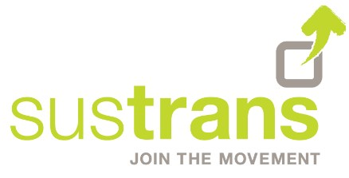
Hands Up Scotland Data Request Form

Your details

Please provide the following basic details about yourself.

Name
Job Title
Organisation
Address
E-mail
Telephone

Research description

Provide a brief overview of your research, in particular your key aims and objectives.

Title
Purpose
Sponsor

Methodology

Outline your research requirements, including how you plan on conducting your research and the timescales involved.

Methodology
Timescale
Contractors

Data requirements

Please identify what data you require from Hands Up Scotland.

Further information on the data available within Hands Up Scotland is contained in the Hands Up Scotland national reports available on Sustrans' website.

Geographical area or Local Authority
School type
Survey Year / Years

If you would like to request ongoing access to the above detailed Hands Up Scotland Survey data, please indicate this here. Please note that if the purpose of your study or project changes in the future, you would need to submit a new data request form. | Y / N

Please note, we may recommend that data is not provided, or is modified in some way, to protect the confidentiality of our respondents.

Timeline

Please give a prospective date by which you hope to receive data from Hands Up Scotland.

We would expect to be able to turn around a simple dataset request in a two to three week period, though more complex requests may take longer. Please note that turnaround time will also vary depending on our available resources, particularly at busy times.

Prospective Date

Justification and Outcomes

Please provide justification for the use of a Hands Up Scotland dataset (as opposed to other alternatives), and how you propose using the resultant analysis.

Use of Hands Up Scotland
Outcomes

Signed declaration

I have read, understood and agreed to the terms and conditions as set out in the Hands Up Scotland Data Request Pro-forma and Guidelines document.

If submitted via email by the person noted in this Pro-forma declaration, a printed name and date will be taken in place of a signature.

Name |  | Date
Signature

Please send the completed form to: HandsUpScotland@sustrans.org.uk

