**Candidate Information**

**Senior Network Development Manager (Strategy), England North**

|  |  |
| --- | --- |
| **Salary:** | Grade H: £35,841 per annum pro rata |
| **Hours:** | Full time. Hours are 37.5 hours per week  We are very happy to discuss working hours to suit individual circumstances. |
| **Contract:** | Permanent |
| **Disclosure:** | Enhanced DBS is not required |
| **Base:** | Hybrid – within reasonable distance of Sustrans offices in Leeds, Manchester or Newcastle with the flexibility to work from home. |
| **Travel:** | This role will involve regular travel most weeks. The focus of this role is in the North of England region; we may occasionally need you to travel further during the course of your work including occasional overnights stays. |
|  | A key part of being the Charity that makes it easier to walk and cycle is that most colleagues cycle, walk, wheel or use public transport for the majority of their work journeys. We support this with access to Sustrans pool bicycles and National Standards Cycling Training. |

**What is the job about?**

The Senior Network Development Manager (Strategy) role will support the Network Development team in defining the strategy and priorities that will fix and grow the National Cycle Network as defined by our [Paths for Everyone](https://www.sustrans.org.uk/about-us/paths-for-everyone) strategy. Assisting in the securing and delivery of a multi-million-pound budget each year, the role will engage with and influence local authorities and partners to make significant upgrades to existing routes as well creating new sections of the National Cycle Network. The role will influence and prioritise

Experienced with Project Management frameworks and principles, the SNDM (Strategy) will work collaboratively with the Network Development team, Design and Engineering colleagues, multiple project managers and other functional teams to resource projects correctly as well as initiate, assist and handover projects as required by our funded programmes.

Before and after of a recent traffic-free NCN upgrade project 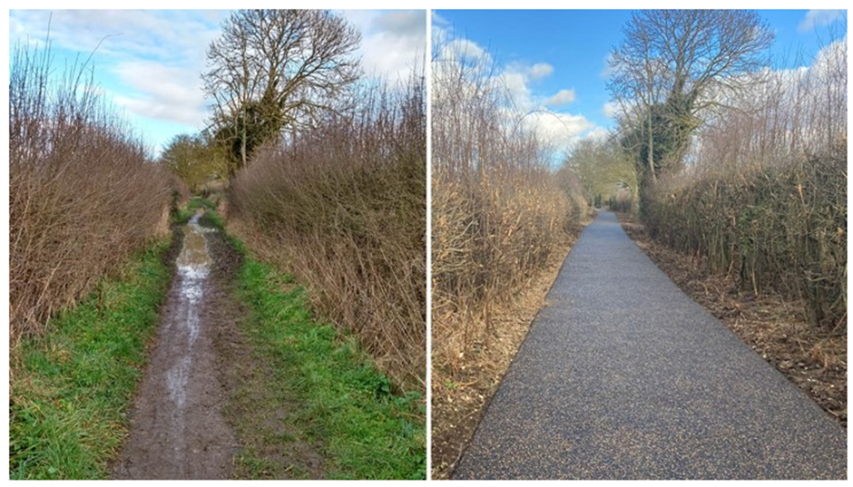

|  |  |
| --- | --- |
| **Where this role sits in the organisational structure:** |  |
|  |  |
|  |  |

**

Public engagement event regarding NCN improvements

Recently completed segregated cycle track on the National Cycle Network

**Job Description - About the Role**

**Overview**

To lead and support a team to develop, influence and prioritise programmes and projects to improve and extend the National Cycle Network and deliver other walking and cycling schemes as part of Sustrans’ Paths for Everyone vision. To plan, co-ordinate, prioritise and support the work of the Network Development Managers ensuring income is maximised and resources focused on impactful projects.

|  |  |
| --- | --- |
| **Where this role sits in the structure** | Reporting into the Head of Network Development, Design & Engineering, England North. This role has line management responsibility. |

Internal relationships:

Head of Network Development, Design & Engineering

Senior Network Development Manager (Projects)

Network Development Managers

Project Officers

Principal Urban Designer

Principal Engineer

England Director, North

Design & Engineering team, England North

Estate Managers

GIS Officers

Other regional staff

Other Network Development teams across the UK

Other Sustrans staff

External relationships:

Local authorities

Partner Agencies

Public and voluntary stakeholder groups

Local cycling and walking groups

Landowners, their tenants, land agents and solicitors

Potential funders

Sustrans volunteers

Community representatives

Members of the public

**Key Responsibilities**

Responsibilities may include:

1. To lead, coach and support the Network Development team in order to plan and prioritise programmes and projects to improve and grow the National Cycle Network.
2. To take a lead and support others in the influencing, promotion and development of successful key relationships with councils and other partners.
3. To provide strategic support and specialist knowledge to the Network Development team and other Sustrans teams;
4. To oversee and manage the Network Development Plan database in order to set priorities and targets against our Paths for Everyone vision for the National Cycle Network.
5. To support the Senior Network Development Manager (Projects) and the Network Development team in managing the delivery of walking, wheeling and cycling projects, including barrier removal, wayfinding and Quiet Lanes;
6. To lead and support the Network Development team in liaising with communities, stakeholders and landowners with respect to route improvements and new route creation;
7. To lead and support the Network Development team in preparing Project Initiation Documents for projects to be delivered by the Design & Engineering team;
8. To undertake the Quality Assurance process for projects and outputs;
9. To ensure that project budgets and resources are well managed and monitored to achieve successful team performance and project outcomes on time and to budget;

**Business development**

1. To seek and assess business development opportunities to add to a pipeline of potential future project work.
2. To take a lead on and assist in bid writing for projects at the direction of the Head of Network Development, Design & Engineering.
3. To contribute toward the development of new ideas, products and innovative strategies for the National Cycle Network.

**Communication and marketing**

1. To support and comply with the charity’s guidance on branding, tone of voice and key messages, positively contributing towards raising Sustrans’ profile.
2. To contribute towards raising the profile of Sustrans, by representing the charity at meetings, activities and events, as required.

**Training and personal development**

1. To attend essential Sustrans training as required by the Charity.
2. To ensure own personal development by working to objectives set as part of the Charity’s appraisal process.

**People management**

1. To manage, develop and coach direct reports by setting clear objectives and monitoring performance to maximise their potential.
2. To work with HR to ensure that training and development of staff is planned effectively and in line with business need.

**Other**

1. Any other duties consistent with the nature and grade of the role as agreed with the line manager.

*We don’t expect anyone to be an expert in all these areas and as long as you meet the person specification we can train you in any gaps.*

**Person Specification**

The following criteria sets out the method by which the skills, knowledge and experience will be assessed against. Our website has a useful guide about how to make a great job application.

|  |  |  |
| --- | --- | --- |
|  | **Application Form** | **Interview** |
| **Specific experience required** |  |  |
| Experience in transport planning or related subject (e.g. engineering, urban design, construction management, land negotiation) |  |  |
| Experience of leading, managing, motivating, and developing a team |  |  |
| Experience in project management and implementation |  |  |
| Experience of working with local stakeholders and the public sector |  |  |
| Experience of working in partnership with other groups / organisations and with a broad range of individuals |  |  |
| **Skills and Abilities** |  |  |
| Excellent written and verbal communications skills |  |  |
| Effective negotiation and advocacy skills |  |  |
| Ability to prioritise and manage own workload |  |  |
| Ability to research, produce reports and deliver presentations |  |  |
| Ability to build and maintain effective working relations at all levels |  |  |
| **Specific knowledge required** |  |  |
| Knowledge of cycling related standards, guidelines and best practice |  |  |
| Knowledge of transport policy and planning |  |  |
| Knowledge of risk assessment and site based health and safety requirements |  |  |

This document does not form part of the contract of employment but does outline our expectations.

If we need to amend this document in the future we will consult with the post holder before doing so.

**Everyone at Sustrans**

**Our values guide us in everything we do:**

* Including everyone
* Having the courage to question
* Acting local, thinking big
* Getting things done, together
* Always learning.
* Sustrans has clear health and safety policies and it is essential that all our colleagues follow these. Very often our teams come into contact with young people through schools work or community engagement so it is everyone’s responsibility at Sustrans to comply with our Safeguarding policies.
* One of our key strategic goals is to be a charity “for everyone”, building a more diverse and inclusive Sustrans. We recognise there is much more we can do to bring together diverse life experiences and voices to enable us to more fully understand, access and represent the communities we work in. Everyone at Sustrans should support this goal and follow our Equality, Diversity and Inclusion policies and procedures.
* Sustrans asks that all our employees develop their skills, knowledge and experience through training and personal development activities. Sustrans will support you with clear objectives and a supportive management culture - our teams tell us that one of the great things about working for Sustrans is the learning and knowledge sharing opportunities.
* It is very important that our colleagues are happy and able to work with IT systems - we use Microsoft programmes and other databases every day (we will train you on our bespoke systems).
* It is also important that everyone at Sustrans supports and follows with the charity’s guidance on branding/key messages and contributes towards raising Sustrans’ profile.
* Everyone at Sustrans is required to work their contracted hours and record their time – if extra hours are worked then we can take time off in lieu.­
* We ask that everyone in Sustrans helps us to develop new opportunities for funded work and builds excellent relationships with our delivery partners and stakeholders.
* Two of our values are *we get things done, together* and *we’re always learning.* Managers often require their teams to get involved in activities that are outside of their job descriptions as we feel this is one of the ways you can learn on the job, develop new skills, make new contacts and progress your career with Sustrans.