Candidate Information

Active Travel Officer, Community Active Travel Programme

Salary: | Grade F: £25,561 per annum (pro rata for part time hours)
Hours: | Full time hours are 37.5 hours per week  This job can be considered for full time or from 30 hours per week. We are happy to discuss working hours to suit individual circumstances.
Contract: | Fixed term until October 2023 (with possibility of extension if further funding is forthcoming).
Disclosure: | Access NI will be required as you may be working with children or young people.
Base: | Sustrans office hub in central Belfast with hybrid working from home and office hub an option.
Travel: | This role will involve regular travel within Belfast City Council area.
 | A key part of being the Charity that makes it easier to walk and cycle is that most colleagues cycle, walk, wheel or use public transport for the majority of their work journeys. We support this with access to a Sustrans bicycle and National Standards on-road Cycling Training.

Job or Project Specific Information

The Community Active Travel Programme (CATP) sees Sustrans working in disadvantaged communities in the Belfast City Council area to encourage, support and train people to travel actively (walking, cycling and wheeling). The project has been running since 2017 and is funded by the Public Health Agency whose remit includes increasing levels of physical activity and improving mental well-being. The role is one of two active travel officer roles. The tasks include encouraging communities and individuals to sign up to the programme, delivering practical cycle training and contributing to the promotion, monitoring and reporting of the programme.

Where this role sits in the structure:

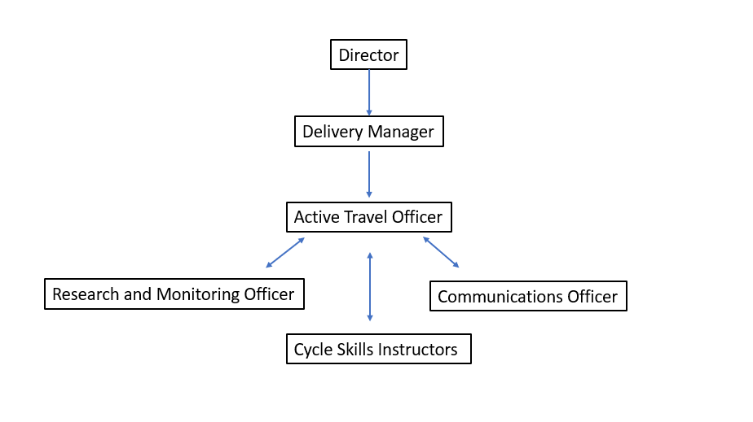

Job Description - About the Role

Overview

Working with communities and other Sustrans colleagues, the post holder will help devise and deliver an innovative programme of activities to overcome barriers that exist to walking and cycling. They will deliver practical activities such as led walks and rides, as well as delivering training including National Standard Cycle Training and develop capacity within the community to ensure the sustainability of the programme through Active Travel Champions and Volunteers.

This programme is part of Sustrans focus on Liveable Cities and Towns and helps deliver on our principal of inclusivity ensuring our work is accessible for everyone.

Where this role sits in the structure | - Line Managed by the Delivery Manager and reporting to the CATP Steering Committee of Sustrans and the PHA.  - Working closely as a team of two with the other Active Travel Officer (ATO) in the Community Active Travel Programme.  - Collaborating with other Active Travel Officers, the Communications Officer and Sustrans’ Research and Monitoring Officer.  - Co-delivering training with the other ATO and the Cycle Skills Instructors.  This role does not have line management responsibility.

Key Responsibilities

Responsibilities may include:

- To create and maintain strong partnerships with community groups, community leaders, third sector organisations, who will be key partners and participants in the project.

- To develop and deliver new innovative opportunities to overcome barriers to active travel that have been identified in each community, such as low levels of bike ownership, lack of confidence travelling actively, and physical barriers raised in Walkability Assessments.

- To deliver a range of practical activities and training to empower and motivate people to travel actively such as National Standard cycle training, led walks and rides, route planning workshops.

- To identify and support potential Active Travel Champions and Volunteers from within the communities, providing them with appropriate training and on-going support so they can deliver activities ensuring sustainability of the programme.

- To ensure the two Active Travel Hubs (at CS Lewis Square and Whiterock) are used to deliver maximum benefit to the local communities

- To build relationships with trained Sustrans Volunteers and the Sustrans Cycle Skills Unit Instructors and involve them where they can assist in the delivery of the programme.

- To order and account for small items in the budget for incentives, events, supply of bicycles and parts.

- To work with the Sustrans Research and Monitoring Unit to record all project activities and deliverables and take a prominent role in producing reports on the project in line with the Monitoring Plan.

- To communicate and promote all aspects of the project through a variety of communication channels. Work with the Sustrans Communications Officer to generate strategic press and social media coverage for the programme.

We don’t expect anyone to be an expert in all these areas and as long as you meet the person specification we can train you in any gaps.

Person Specification
The following criteria sets out the method by which the skills, knowledge and experience will be assessed against. Our website has a useful guide about how to make a great job application.

 | Application Form | Interview
Specific experience required
Experience of working on practical projects which had community involvement as a core element

Experience in the delivery and/or participation in walking or cycling activities

Experience of delivering activities in an outdoor setting
Skills and Abilities
Excellent interpersonal and networking skills, which result in productive relationships with community group leaders and members of the public

Ability to motivate and train others to achieve behavioural change

Good written, verbal communication and presentation skills.

Strong organisational skills and proven ability to plan and prioritise own workload

Specific qualifications/ training required
IT literate: competent user of email, internet, Word and Excel

Specific knowledge required
Knowledge of working with communities based in areas of disadvantage

Experience of planning and delivering a programme of activities

Knowledge of effective working with volunteers

Competent user of popular social media channels

Committed to walking, cycling and the ideals of Sustrans

Prepared to walk or cycle for most work journeys

Experience of data collection and report writing

This document does not form part of the contract of employment but does outline our expectations.
If we need to amend this document in the future we will consult with the post holder before doing so.

Everyone at Sustrans

Our values guide us in everything we do:
- Including everyone
- Having the courage to question
- Acting local, thinking big
- Getting things done, together
- Always learning.

- Sustrans has clear health and safety policies and it is essential that all our colleagues follow these. Very often our teams come into contact with young people through schools work or community engagement so it is everyone’s responsibility at Sustrans to comply with our Safeguarding policies.

- One of our key strategic goals is to be a charity “for everyone”, building a more diverse and inclusive Sustrans. We recognise there is much more we can do to bring together diverse life experiences and voices to enable us to more fully understand, access and represent the communities we work in. Everyone at Sustrans should support this goal and follow our Equality, Diversity and Inclusion policies and procedures.

- Sustrans asks that all our employees develop their skills, knowledge and experience through training and personal development activities. Sustrans will support you with clear objectives and a supportive management culture - our teams tell us that one of the great things about working for Sustrans is the learning and knowledge sharing opportunities.

- It is very important that our colleagues are happy and able to work with IT systems - we use Microsoft programmes and other databases every day (we will train you on our bespoke systems).

- It is also important that everyone at Sustrans supports and follows with the charity’s guidance on branding/key messages and contributes towards raising Sustrans’ profile.

- Everyone at Sustrans is required to work their contracted hours and record their time – if extra hours are worked then we can take time off in lieu.

- We ask that everyone in Sustrans helps us to develop new opportunities for funded work and builds excellent relationships with our delivery partners and stakeholders.

- Two of our values are we get things done, together and we’re always learning. Managers often require their teams to get involved in activities that are outside of their job descriptions as we feel this is one of the ways you can learn on the job, develop new skills, make new contacts and progress your career with Sustrans.

