Candidate Information

Project Manager, Paths for Everyone, Norfolk & Suffolk (England, Midlands and East)
Salary: | Grade G: £28,499 per annum pro rata
Hours: | Full time hours are 37.5 hours per week  This job can be considered for full time or from 30 hours per week. We are very happy to discuss working hours to suit individual circumstances.
Contract: | Maternity Cover
Disclosure: | Enhanced DBS is not required for this position as the post holder will not be working with children in educational settings.
Base: | Hybrid – within reasonable distance of Sustrans offices in Peterborough with the flexibility to work from home.  This role will have a focus on Suffolk and Norfolk.
Travel: | This role will involve regular travel. The focus of this role is in the England Midlands and East region; we may occasionally need you to travel further during the course of your work including occasional overnight stays, although most of your work will be based in the Hertfordshire and Essex area.
 | A key part of being the Charity that makes it easier to walk and cycle is that most colleagues cycle, walk, wheel or use public transport for the majority of their work journeys. We support this with access to a Sustrans pool bicycle and National Standards Cycling Training.

Why is this role important to us?
We have a 20-year plan to make the 16,000 mile long National Cycle Network, safer and more accessible for everyone. We aspire to take every mile to very good or good standard by 2040 and we want to double the traffic free sections from 5,000 to 10,000 miles getting routes off fast or busy roads. We are encouraging and inspiring more and different people to share, respect and enjoy the Network and we are helping communities and users shape and maintain their paths. We are working to raise funds from a wide range of sources that will be needed to secure the future success of this national asset.
Where this role sits in the structure:

Meet some of the team!
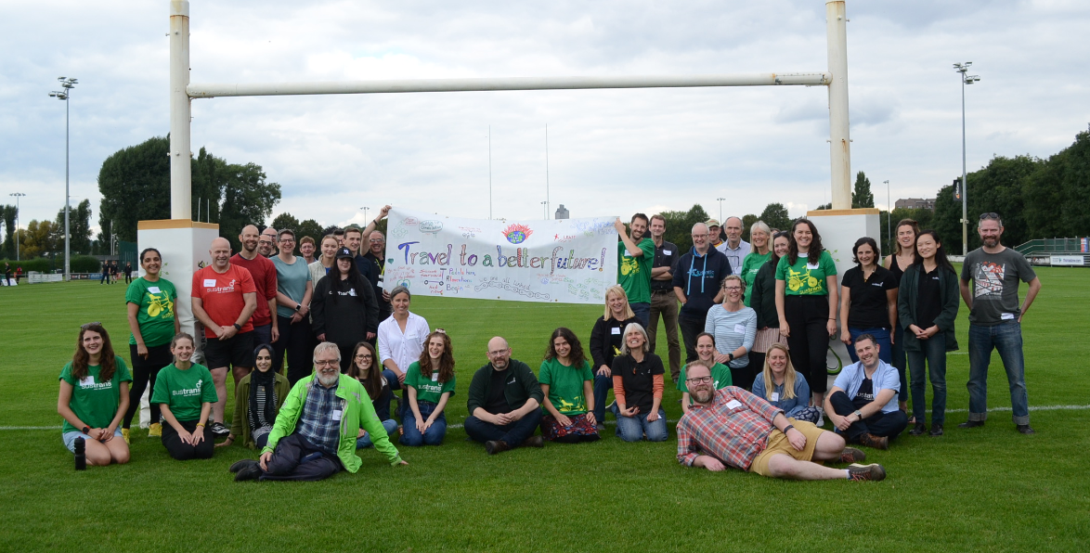
Job Description - About the Role
Overview
The Network Development Team, England Midlands and East, proactively develop walking and cycling schemes, including the National Cycle Network (NCN) across England. As a valued member of this team you will help maintain the National Cycle Network in your region, you will help fund it by developing business opportunities and you will help fix and grow it by delivering impactful projects to scope, to budget and on time. This role will have a focus on Hertfordshire and Essex.
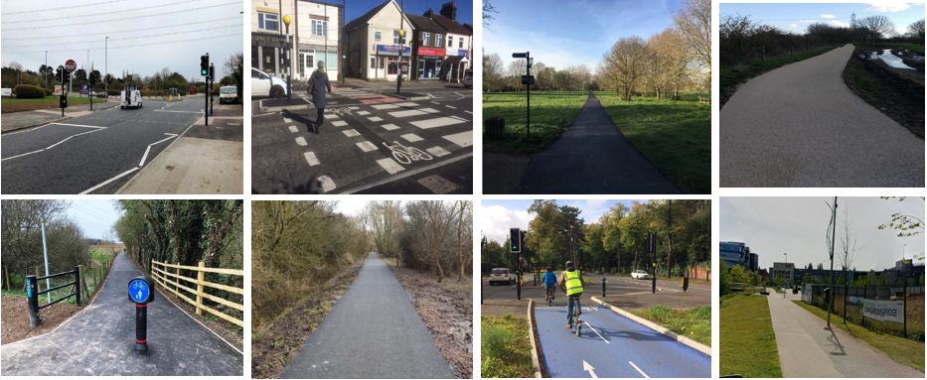
Where this role sits in the structure
Reporting into a Senior Network Development Manager/ Senior Project manager, England Midlands and East.
Working closely with:
Senior Network Development Manager/ Senior Project Manager, England Midlands and East
Network Development Managers, England Midlands and East
Senior Technical Officers, England Midlands and East
Head of Network Development, England Midlands and East
Design & Engineering team
Land Managers
GIS Manager
Volunteer Co-ordinator and other teams in England Midlands and East
External:
Local authority and other clients and funders, including key officers and decision-makers
Local volunteers and supporters, local communities and many more organizations.
Landowners and other key delivery partners

This role does not have line management responsibility.

Key Responsibilities
Responsibilities may include:
Delivery of projects or services:
- To deliver feasibility studies, walking and cycling network plans and other paid services in line with partner, funder and Sustrans requirements.
- To project manage, working with colleagues and contractors to ensure the delivery of network development infrastructure projects.
- To engage and negotiate with landowners to assemble land for routes.
- To coordinate and influence the strategic development of the National Cycle Network (NCN) to meet Sustrans’ Paths for Everyone strategy.
- To act as first point of contact for Sustrans’ infrastructure work in several local authority areas. (Primarily Hertfordshire and Essex).
- To undertake work on agreed projects or as part of a regional and national delivery team when required.
- To ensure that planning applications and strategic planning documents are monitored and commented on in the best interests of Sustrans.
- To assist the Land Manager and Volunteer Coordinator to support Sustrans’ volunteers in the local area in inspection, maintenance and workdays on the NCN.
- To ensure all activities follow Sustrans’ Project Management Framework (PMF) and Customer Relationship Management (CRM) procedures.
- To work with volunteers and other partners such as highway authorities to ensure that the NCN is properly signed and maintained.
- To lead on ensuring that regional data for central GIS systems is up to date, including working with volunteers and technicians to ensure NCN mapping is accurate.
- To comply with relevant legislation including Construction Design Management (CDM) legislation. Full in-house training will be provided.

Business development:
- To participate in bid writing for projects at the direction of the Head of Network Development.
- To assist the development and promotion of a range of sustainable transport initiatives across the portfolio of Sustrans’ activities as agreed with the England Director, Midlands and East and Head of Network Development.
- To work with the local authorities and local communities to develop infrastructure schemes.
- To pursue business development opportunities, maintaining key local authority and partner relationships.
- To contribute toward the development of new ideas and innovative strategies for product development, marketing, branding, or business opportunities.
Communication and marketing:
- To contribute towards raising the profile of Sustrans, by representing the charity at meetings, activities and events, as required.
- To act as the main point of contact regarding cycling and walking infrastructure for Sustrans in your local authority areas.
Training and personal development
- To attend essential Sustrans training as required by the Charity.
- To ensure own personal development by working to objectives set as part of the Charity’s appraisal process.
Health & Safety, Safeguarding and Equality, Diversity and Inclusion:
- To support and comply with the organisation’s policy for the management of Health and Safety.
- To support and comply with the organisation’s policies for the management of safeguarding.
- To support and comply with the organisation’s policy and procedures relating to Equality, Diversity and Inclusion and apply principles of best practice in own role.
Other
- To undertake any other duties consistent with the nature and grade of the role as agreed with the line manager.

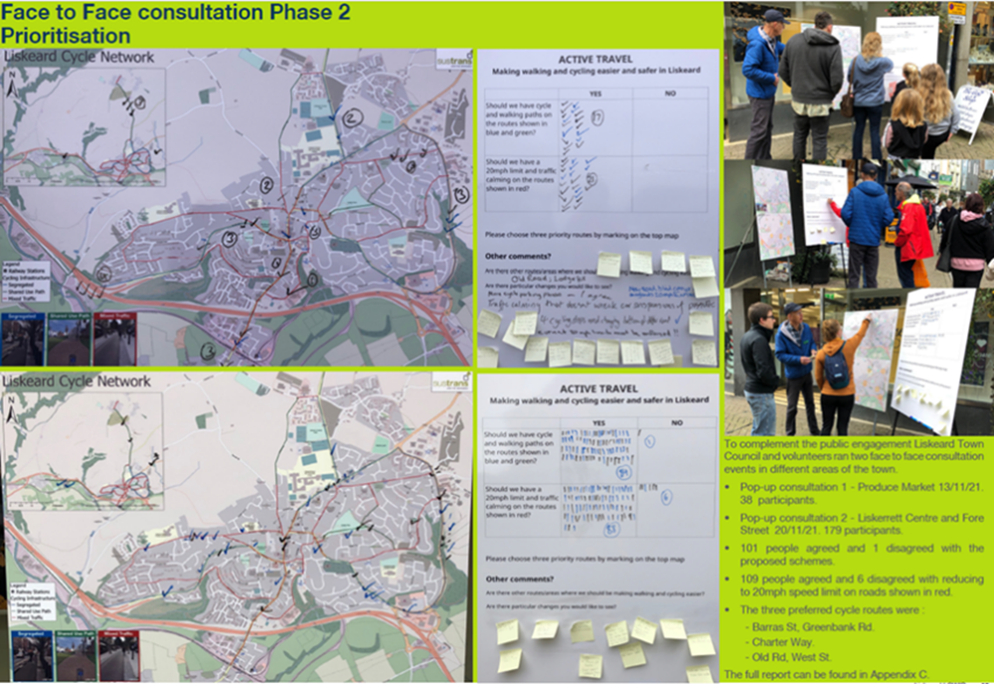
Person Specification
The following criteria sets out the method by which the skills, knowledge and experience will be assessed against. Our website has a useful guide about how to make a great job application.

 | Application Form | Interview
Specific experience required
Experience in project management from end to end of the project
Experience in preparing and managing project budgets
Experience of working in partnership with local stakeholders and the public sector and/ or with a broad range of individuals
Interest in using and learning how to use Geographical Information Systems (GIS) mapping software or already have experience in using it.
Skills and Abilities
Shows passion and enthusiasm for the role.
Excellent written and verbal communications skills
Effective negotiation and advocacy skills
Ability to prioritise and manage own workload
Ability to research and produce excellent readable technical reports
Ability to build and maintain effective working relations at all levels
Excellent presentation skills
Ability to manage and prioritise own workload
IT literate
Can demonstrate commitment to Sustrans’ vision and mission

This document does not form part of the contract of employment but does outline our expectations.
If we need to amend this document in the future we will consult with the post holder before doing so.

Everyone at Sustrans
Our values guide us in everything we do:
- Including everyone
- Having the courage to question
- Acting local, thinking big
- Getting things done, together
- Always learning.

- Sustrans has clear health and safety policies and it is essential that all our colleagues follow these. Very often our teams come into contact with young people through schools work or community engagement so it is everyone’s responsibility at Sustrans to comply with our Safeguarding policies.

- One of our key strategic goals is to be a charity “for everyone”, building a more diverse and inclusive Sustrans. We recognise there is much more we can do to bring together diverse life experiences and voices to enable us to more fully understand, access and represent the communities we work in. Everyone at Sustrans should support this goal and follow our Equality, Diversity and Inclusion policies and procedures.

- Sustrans asks that all our employees develop their skills, knowledge and experience through training and personal development activities. Sustrans will support you with clear objectives and a supportive management culture - our teams tell us that one of the great things about working for Sustrans is the learning and knowledge sharing opportunities.

- It is very important that our colleagues are happy and able to work with IT systems - we use Microsoft programmes and other databases every day (we will train you on our bespoke systems).

- It is also important that everyone at Sustrans supports and follows with the charity’s guidance on branding/key messages and contributes towards raising Sustrans’ profile.

- Everyone at Sustrans is required to work their contracted hours and record their time – if extra hours are worked then we can take time off in lieu.

- We ask that everyone in Sustrans helps us to develop new opportunities for funded work and builds excellent relationships with our delivery partners and stakeholders.

- Two of our values are we get things done, together and we’re always learning. Managers often require their teams to get involved in activities that are outside of their job descriptions as we feel this is one of the ways you can learn on the job, develop new skills, make new contacts and progress your career with Sustrans.

What do the team say?
Rosalind (Network Development Manager):
My role as a Network Development Manager involves managing a wide variety of projects from writing feasibility studies to overseeing the construction of new paths; engaging with Local Authorities on NCN related schemes and Local Cycling and Walking Infrastructure Plans; creating and updating Network Development Plans for each county, identifying potential areas where the network could be enhanced to Paths for Everyone standard; connecting with volunteers to assist with various tasks; collaborating with colleagues from other teams (ecology, engineers, planning advisors, community engagement officers etc).
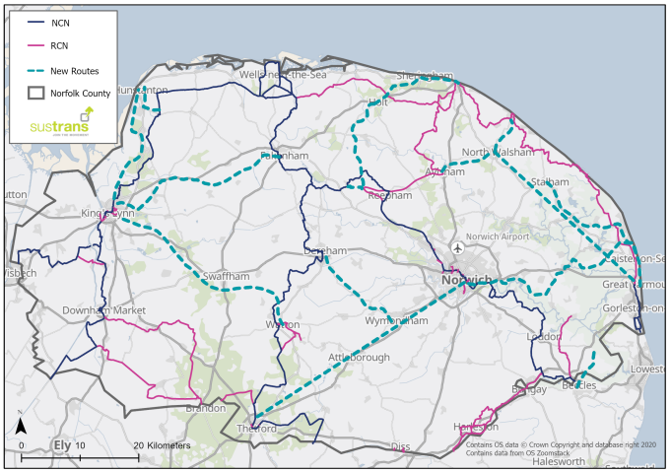
From joining Sustrans with limited experience in Project Management, I have received overwhelming support from colleagues across various departments which has allowed me to develop new skills in ecology, design and engineering, community engagement etc. Sustrans is a great organisation to work for with a supportive and enthusiastic team of individuals all working to make it easier for people to walk and cycle.

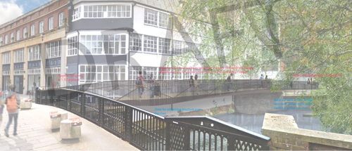
Snow (Network Development Technical Officer):

“ In the Network development team, we have the opportunity to implement active travel in towns and cities from a strategic level. Audit studies and the Local Cycling and Walking Infrastructure Plans (LCWIP) allow us to analyse cities from a high-level perspective and propose cycling and walking infrastructure to make it easier for people to walk and cycle. An example of this are the Audits for walking and cycling in Leicestershire (see image below) where we proposed 7 cycle corridors linking Blaby and walking zones along the areas with more pedestrian activity.
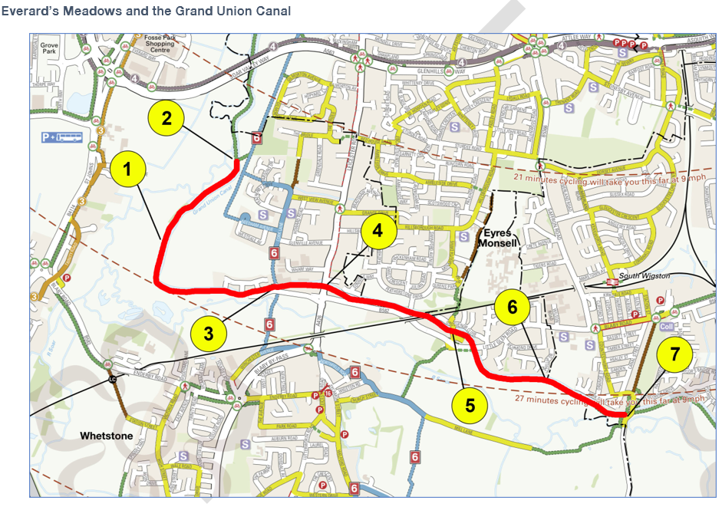
When we work on these projects we are in constant communication and collaboration with other teams in Sustrans. Some interventions such as barrier redesign or crossing improvements may need technical advice from the Design and Engineering team. Or in other cases when a cycling corridor goes along a rural area, the ecological team provides their input, allowing us to deliver studies and projects with a multidisciplinary perspective.
But not everything is technical work from a desktop, we are also in tight contact with communities. An important part of our job is to visit the different places that we are working on, understand the area, to know people's mobilities needs, and be in contact with local authorities.

