Candidate Information

Principal Engineer, London

Salary: | Grade I: £37,004 per annum (pro rata for part time hours), plus  - A £3,995pa (pro rata) London Weighting Allowance and  - A £6,975pa (pro rata) Recruitment & Retention Allowance
Hours: | Full time hours are 37.5 hours per week  We are very happy to discuss working hours to suit individual circumstances. This role is particularly suitable for job share / compressed hours / school hours.
Contract: | Permanent
Disclosure: | Enhanced DBS is not required.
Base: | Blended home / office working. Sustrans London office at  254 Cambridge Heath Road, E9 2DA
Travel: | The focus of this role is in the London region; we may occasionally need you travel further during the course of your work.
 | A key part of being the Charity that makes it easier to walk and cycle is that most colleagues cycle, walk, wheel or use public transport for the majority of their work journeys. We support this with access to a Sustrans pool bicycle and National Standards Cycling Training.

Job Specific Information

This is an exciting opportunity to join our Built Environment team, working with local communities to reclaim streets as public spaces, and create healthier, happier, fairer cities that are accessible to all.
You will have the opportunity to lead projects which tackle some of the city’s greatest challenges, including the response to the climate emergency, the inequitable distribution of (and access to) green space, the social injustice of private vehicle dominance and the realisation of equitable and joyful public space for all.

Where this role sits within Sustrans London:

Meet the team! (Mar 2022, we’ve grown since!)
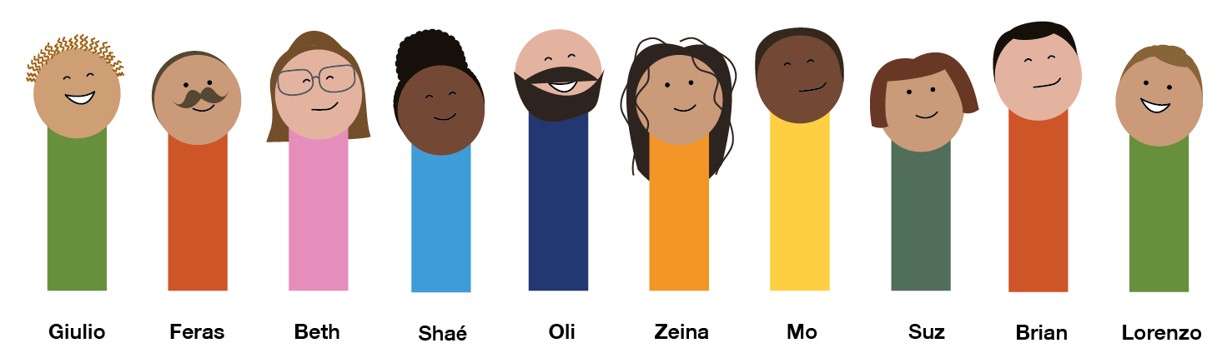
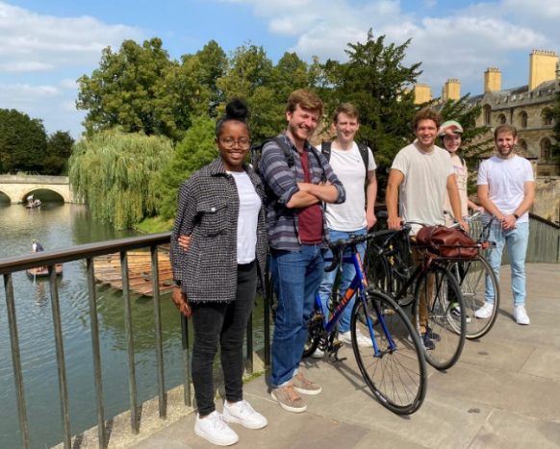
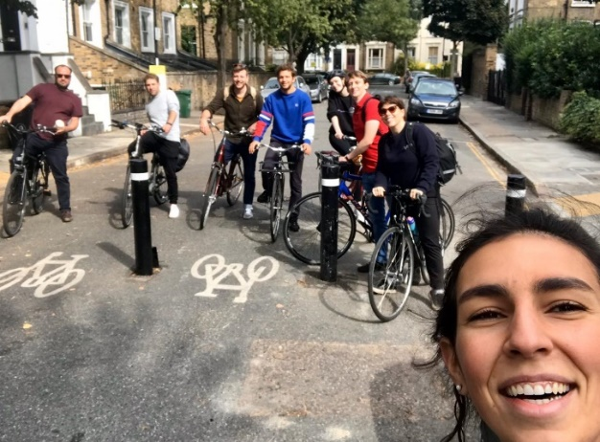

Some reads written by us:
Giulio Ferrini on repurposing our streets for walking, cycling and play
Zeina Hawa on School Streets and recovery plans
Interview with Suzanne King and Zeina Hawa

Job Description - About the Role

Overview

The post holder will play a critical role in the delivery of high-quality walking, cycling and wheeling public realm schemes across London, positioning Sustrans as experts in the design of equitable & liveable towns and cities.
We are looking for someone who can champion people-focused street design, building our partners’ ambition and influencing decision-makers to maximise our impact. You will be able to shape our design offer to ensure it remains innovative and relevant to the challenges Londoners face, as well as develop our relationships with communities and stakeholders.
You will be leading on projects and programmes, providing expertise and quality assurance to community groups and clients at all design stages from conception to delivery. You will be responsible for supporting the team in delivery, ensuring responsibilities for staff well-being and development are not only met but exceeded.
We enjoy working and growing together as a team, and value the contribution and expertise of all members. We will support you to find a work-life balance that best meets your needs and provide professional development opportunities, including an ICE-approved training scheme.
Where this role sits in the structure
- Reporting to the Head of Built Environment
- Working closely with all members of the interdisciplinary Built Environment team, as well as colleagues from the Neighbourhoods & Networks and Collaborative Design teams. Occasional working with colleagues from other regions.
- You will be responsible for line managing multiple team members

Key Responsibilities
- Lead on the production, review and approval of engineering drawings and technical reports
- Lead on the delivery of projects: prepare bids, allocate resources, manage risks, coordinate work and ensure delivery to programme and budget
- Provide technical assurance and expertise to colleagues, partners and stakeholders
- Manage design risks and ensure the team complies with the requirements of CDM 2015
- Lead on business development opportunities, including shaping our offer to ensure it remains innovative and relevant. Identify new areas of work and grow new or existing relationships.
- Create a collaborative, supportive and inclusive environment which prioritises colleagues’ mental and physical health
- Develop and implement opportunities for staff and team development
- Recognise the limits of their own and the team’s expertise / lived experience, and engage others to ensure our projects work for everyone
- Influence partners to maximise design / project ambition and impact

We don’t expect anyone to be an expert in all these areas and, as long as you meet the person specification, we can train you in any gaps.

Person Specification
The following criteria sets out the method by which the skills, knowledge and experience will be assessed against, and at what stage of the process the criteria will be assessed. Our website has a useful guide about how to make a great job application.

 | Application Form | Interview
Specific experience required
Quality assurance on healthy streets design projects
Leading highways engineering projects through all project stages, including tender & construction
Health and safety management, including CDM
Project management and implementation to budget and deadlines
Meaningful community engagement and co-design
Skills and Abilities
Expertise in a range of design packages
Building strategic relationships, influencing partners and clients to increase ambition and impact
Communicating with technical and non-technical audiences at workshops, conferences and training sessions (internal and external)
Imaginative approach to problem solving
Managing teams: allocating and managing workload and resources; supporting colleague development and placing empathy & well-being at the heart of the team
Leading teams: motivating and inspiring colleagues; providing technical expertise, training, guidance & assurance
Working within a diverse environment
Specific qualifications/ training required
Civil engineering experience (HNC or equivalent work experience)
Professional membership of professionally recognised body or equivalent experience
Specific knowledge required
Inclusive design: understanding the relationship between streets and social justice

This document does not form part of the contract of employment but does outline our expectations.
If we need to amend this document in the future we will consult with the post holder before doing so.

Everyone at Sustrans

Our values guide us in everything we do:
- Including everyone
- Having the courage to question
- Acting local, thinking big
- Getting things done, together
- Always learning.

Additionally:
- Sustrans has clear health and safety policies and it is essential that all our colleagues follow these. Very often our teams come into contact with young people through schools work or community engagement so it is everyone’s responsibility at Sustrans to comply with our Safeguarding policies.

- One of our key strategic goals is to be a charity “for everyone”, building a more diverse and inclusive Sustrans. We recognise there is much more we can do to bring together diverse life experiences and voices to enable us to more fully understand, access and represent the communities we work in. Everyone at Sustrans should support this goal and follow our Equality, Diversity and Inclusion policies and procedures.

- Sustrans asks that all our employees develop their skills, knowledge and experience through training and personal development activities. Sustrans will support you with clear objectives and a supportive management culture - our teams tell us that one of the great things about working for Sustrans is the learning and knowledge sharing opportunities.

- It is very important that our colleagues are happy and able to work with IT systems - we use Microsoft programmes and other databases every day (we will train you on our bespoke systems).

- It is also important that everyone at Sustrans supports and follows with the charity’s guidance on branding/key messages and contributes towards raising Sustrans’ profile.

- Everyone at Sustrans is required to work their contracted hours and record their time – if extra hours are worked then we can take time off in lieu.

- We ask that everyone in Sustrans helps us to develop new opportunities for funded work and builds excellent relationships with our delivery partners and stakeholders.

- Two of our values are we get things done, together and we’re always learning. Managers often require their teams to get involved in activities that are outside of their job descriptions as we feel this is one of the ways you can learn on the job, develop new skills, make new contacts and progress your career with Sustrans.

