Candidate Information

Senior Network Development Manager (SDNM), England South

Salary: | Grade H: £32,475 per annum pro rata
Hours: | Full time. Hours are 37.5 hours per week  We are very happy to discuss working hours to suit individual circumstances.
Contract: | Permanent
Disclosure: | Enhanced DBS is not required
Base: | Hybrid – within reasonable distance of Sustrans offices in Reading or Bristol with the flexibility to work from home.
Travel: | This role will involve regular travel most weeks. The focus of this role is in the South West of England region; we may occasionally need you to travel further during the course of your work including occasional overnights stays.
 | A key part of being the Charity that makes it easier to walk and cycle is that most colleagues cycle, walk, wheel or use public transport for the majority of their work journeys. We support this with access to a Sustrans pool bicycle and National Standards Cycling Training.

What is the job about?
The Senior Network Development Manager (SNDM) will support a small team in the delivery of our Paths for Everyone strategy. Overseeing a budget of several million pounds a year, the role will ensure the delivery of impactful projects on the National Cycle Network and other local networks. Experienced with Project Management Frameworks, the SNDM will work collaboratively with the Network Development team, the Design and Engineering Team, the Land Team and the Volunteer Officers, sharing a common culture and purpose to align with the Sustrans vision, mission and Theory of Change.
Working in partnership with Local Authorities is crucial, collaborating with them to create a 20-year plan for the delivery of the Network, that aligns with the Department of Transport’s latest guidance on walking and cycling (Local Transport Note 1/20). There are many other stakeholders to engage with, including Sustrans volunteers, who help make the Network safe for everyone to enjoy.
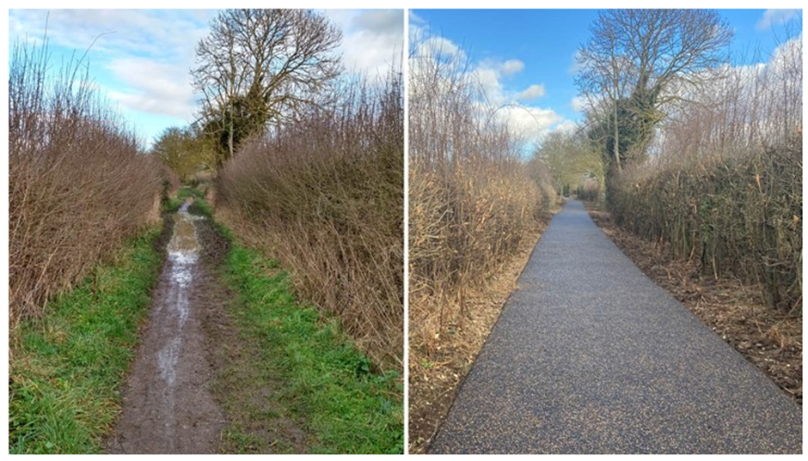
Before and after of a recent traffic-free NCN upgrade project
Where this role sits in the organizational structure:

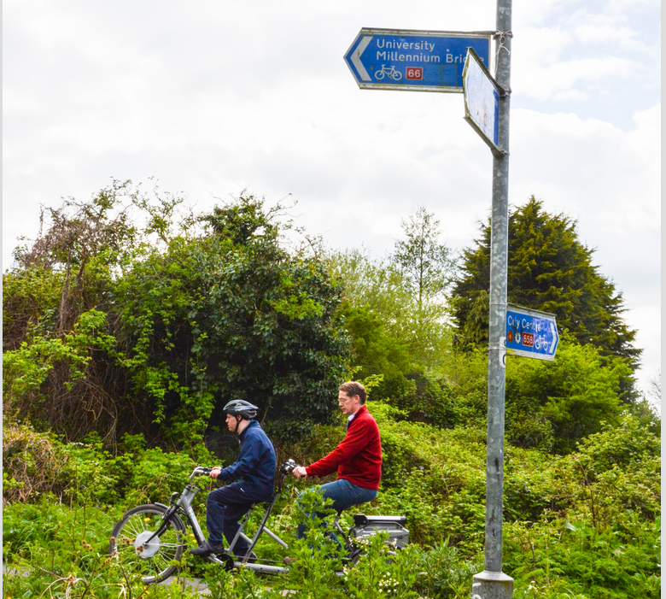

Making it easier for everyone to walk, cycle and wheel.

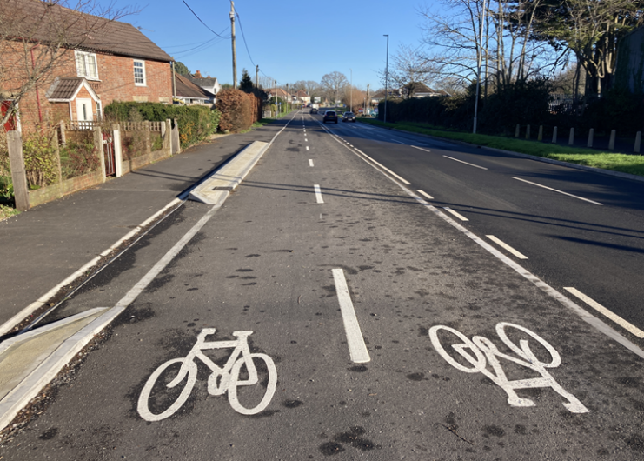
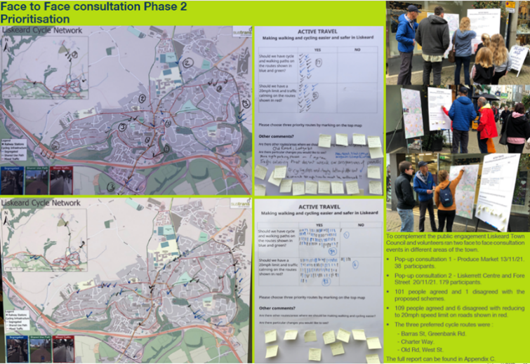
Public engagement event regarding NCN improvements
Recently completed segregated cycle track on the National Cycle Network

Job Description - About the Role

Overview

To manage programmes and projects to improve and extend the National Cycle Network and deliver other walking and cycling schemes as part of Sustrans’ Paths for Everyone vision. To plan, co-ordinate, prioritise and support the work of the Network Development Managers ensuring income is maximised and resources focused on impactful projects.

Where this role sits in the structure | Reporting into the Head of Network Development, England South. This role has line management responsibility for five team members.
Internal relationships:
Head of Network Development, England South
Senior Network Development Manager, England South East
Network Development Managers
Design & Engineering team, England South
Director, England South
Delivery team, England South
Partnerships team, England South
Land Managers
GIS Manager
Volunteer Coordinators
Other Network Development teams across the UK
Engineering and design teams across the UK

External relationships:
Local authority and other clients and funders, including key senior officers and decision-makers
Local Enterprise Partnerships (LEPs)
Devolved administrations and Combined Transport Authorities
Local volunteers and supporters
Landowners and other key delivery partners

Key Responsibilities

Delivery of projects or services:
- To programme manage central government funding programmes to deliver walking and cycling schemes.
- To plan, co-ordinate, prioritise and support the work of the Network Development Managers ensuring income is maximised and resources are focused on projects with clear alignment with Sustrans’ vision and mission.
- To ensure the Network Development team is maximising its utilisation rates, tracking progress via timesheets and minimising over or under utilisation by effective forward planning.
- To deliver feasibility studies, cycle network plans and other paid services in line with partner, funder and Sustrans requirements.
- To coordinate and influence the strategic development of the National Cycle Network (NCN) in the South region.
- To undertake work individually on agreed projects or as part of a regional and national delivery team when required.
- To ensure all activities follow Sustrans’ Project Management Framework (PMF) and Customer Relationship Management (CRM) procedures

Business development:
- To participate in bid writing for projects at the direction of the Head of Network Development.
- To assist the development and promotion of a range of sustainable transport initiatives across the portfolio of Sustrans’ activities as agreed with the England Director, South and Head of Network Development.
- To work with the local authorities and local communities to develop infrastructure schemes.
- To pursue business development opportunities across the South region, maintaining key local authority and partner relationships.
- To contribute toward the development of new ideas and innovative strategies for product development, marketing, branding, or business opportunities.

Communication and marketing:
- To contribute towards raising the profile of Sustrans, by representing the charity at meetings, activities and events, as required.

People management
- To manage, develop and coach the Network Development team members by setting clear objectives and monitoring performance to maximise their potential.
- To work with HR to ensure that training and development of staff is planned effectively and in line with business need.

We don’t expect anyone to be an expert in all these areas and as long as you meet the person specification we can train you in any gaps.

Person Specification
The following criteria sets out the method by which the skills, knowledge and experience will be assessed against. Our website has a useful guide about how to make a great job application.

 | Application Form | Interview
Specific experience required
Experience in transport planning or related subject (e.g. engineering, urban design, construction management, land negotiation)
Experience of leading, managing, motivating, and developing a team
Experience in project management and implementation
Experience of working with local stakeholders and the public sector
Experience of working in partnership with other groups / organisations and with a broad range of individuals
Skills and Abilities
Excellent written and verbal communications skills
Effective negotiation and advocacy skills
Ability to motivate others
Ability to prioritise and manage own workload
Ability to research and produce reports
Ability to build and maintain effective working relations at all levels
Excellent presentation skills
Specific knowledge required
Knowledge of cycling related standards, guidelines and best practice
Knowledge of transport policy and planning
Knowledge of risk assessment and site based health and safety requirements

This document does not form part of the contract of employment but does outline our expectations.
If we need to amend this document in the future we will consult with the post holder before doing so.
Everyone at Sustrans

Our values guide us in everything we do:
- Including everyone
- Having the courage to question
- Acting local, thinking big
- Getting things done, together
- Always learning.

- Sustrans has clear health and safety policies and it is essential that all our colleagues follow these. Very often our teams come into contact with young people through schools work or community engagement so it is everyone’s responsibility at Sustrans to comply with our Safeguarding policies.

- One of our key strategic goals is to be a charity “for everyone”, building a more diverse and inclusive Sustrans. We recognise there is much more we can do to bring together diverse life experiences and voices to enable us to more fully understand, access and represent the communities we work in. Everyone at Sustrans should support this goal and follow our Equality, Diversity and Inclusion policies and procedures.

- Sustrans asks that all our employees develop their skills, knowledge and experience through training and personal development activities. Sustrans will support you with clear objectives and a supportive management culture - our teams tell us that one of the great things about working for Sustrans is the learning and knowledge sharing opportunities.

- It is very important that our colleagues are happy and able to work with IT systems - we use Microsoft programmes and other databases every day (we will train you on our bespoke systems).

- It is also important that everyone at Sustrans supports and follows with the charity’s guidance on branding/key messages and contributes towards raising Sustrans’ profile.

- Everyone at Sustrans is required to work their contracted hours and record their time – if extra hours are worked then we can take time off in lieu.

- We ask that everyone in Sustrans helps us to develop new opportunities for funded work and builds excellent relationships with our delivery partners and stakeholders.

- Two of our values are we get things done, together and we’re always learning. Managers often require their teams to get involved in activities that are outside of their job descriptions as we feel this is one of the ways you can learn on the job, develop new skills, make new contacts and progress your career with Sustrans.

