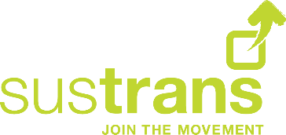
Sustrans’ Carbon Reduction Plan
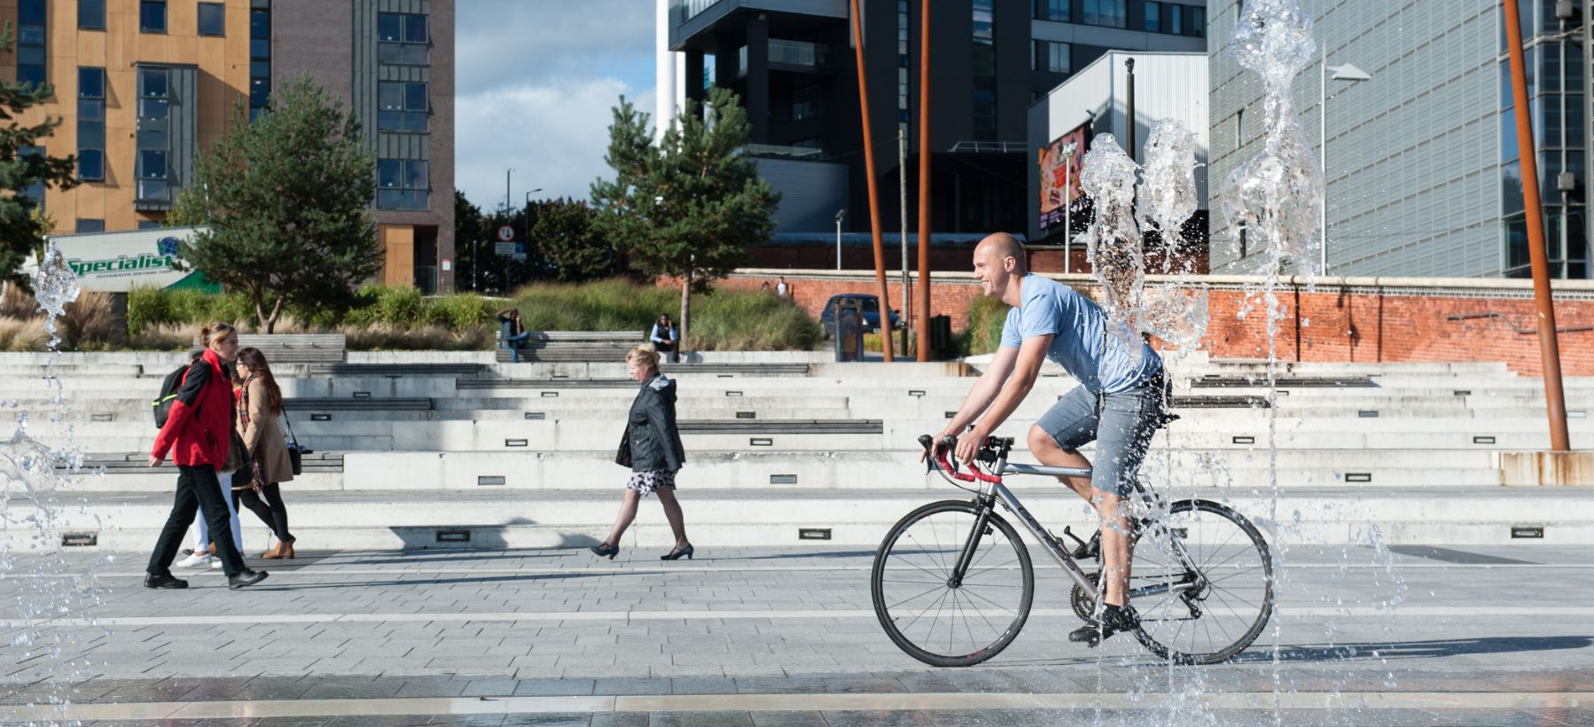
Net Zero 2040
21 March 2023
To find out more, please contact: Jen Strong
jen.strong@sustrans.org.uk
Sustrans is the charity making it easier for people to walk and cycle.
We connect people and places, create liveable neighbourhoods, transform the school run and deliver a happier, healthier commute.
Join us on our journey.
www.sustrans.org.uk
Registered Charity No. 326550 (England and Wales) SC039263 (Scotland).
Cover photo credit: Livia Lazar

Contents
Contents 1
Introduction 2
Our baseline emissions 2
Note on our figures 3
Our commitments 4
Actions to reduce our emissions 5

Introduction
Responding to the climate crisis
The climate crisis represents an existential threat to the planet and its inhabitants. Sustrans recognises the urgent need to address this crisis, and we are committed to taking meaningful action to reduce our own carbon footprint and to promote sustainable travel options to help mitigate the impacts of climate change.
We aim to achieve net zero by 2040, while decarbonising our most direct emissions by 2030. This plan outlines our starting point and approach to achieving this goal.

Our carbon management and baseline emissions
Source of emissions (2021-22) | tCO2e
Scope 1 | 78
Fuel for site equipment | 7
Gas | 10
Own vehicles | 60
Scope 2 | 28
Electricity | 28
Scope 3 | 10,655 (approx.)
Business travel | 122
Construction | 4,900 (approx.)
Fuel and energy-related activities | 27
Procurement | 5,400 (approx..)
WFH | 153
Employee commuting | 53
Total | 10,760
Our approach to carbon management is aligned with the Greenhouse Gas Protocol. We are committed to following best practice and comprehensively target and report our material emission sources.
Our GHG inventory accounts for the vast majority of Sustrans emissions over which we have operational control, which includes all direct and indirect emissions.
Since 2019, we have been reporting our carbon emissions using the Streamlined Energy and Carbon Reporting methodology (direct Scope 1&2 emissions only) and this is the first year we are reporting a more comprehensive picture covering the vast majority of our emissions across all three scopes. Whilst we made the best effort to report accurate data, there are areas where we recognise we can improve our methodologies, most notably on our procurement and construction activities. We are committed to improving the accuracy of our data and reporting our full scope of carbon emissions in future.

Note on our figures
Employee commuting
Our employee commuting carbon emissions are estimated based on a staff commuting survey.
Purchased good and services (procurement)
For our 2021/22 financial year reporting, we have used financial data on spend (in £) to calculate and report on our emissions.
We want to eventually move away from spend data by working with our suppliers to gain more accurate data. We want to ask about lifecycle emissions of products and services purchased where possible, however not all of our suppliers will have this information – this might be the case especially with smaller, local suppliers. It is likely this process will take us several years before we have substantially better data.
Construction
For our 2021/22 financial year reporting, we have used financial data on spend (in £) to calculate and report on our emissions.
For future reporting, we intend to work with our suppliers to improve the accuracy of our data, e.g. by reporting on fuel use on our construction sites and by calculating emissions from materials used. We have started the process of adopting the PAS 2080 Carbon Management in Infrastructure standard.
Investments (to include grant giving)
There were no investments associated with our organisation in 2021/22. We will report on our investment emissions if this becomes relevant for Sustrans.
Grant giving to projects is currently not included in our baseline and reporting. We will look to include this in future reporting, considering the environmental impact of projects and reflect this in our decision making.
Materiality note
We have conducted a materiality assessment to identify all significant sources of emissions within our operations. We have included only categories where we have applicable activities or where activities have a material impact on our emissions.

Our commitments
Sustrans wants to be a sector leader in its approach to carbon reduction. We have set ourselves ambitious and progressive targets that reflect our determination to decarbonise our organisation.
We are committed to:
- Reducing our Scope 1, 2 carbon emissions to zero by 2030.
- Halving our operational Scope 3 emission by 50% and removing the remaining emissions by 2030.
- Reducing our emissions from procurement and construction to net zero by 2040.
- Developing our intermediate, 2030 procurement and construction targets by 2025.

Our reduction pathway is based on:
- our baseline inventory,
- our current understanding of the existing technical solutions and their expected development,
- our understanding of government policy and its forecasted impacts on Sustrans and its carbon emissions.
Whilst Sustrans is committed to ambitious action on climate change, we are a charity and we need to balance our resources, achievement of our strategic objectives, the public procurement rules with our carbon reduction programme. To ensure that targets are aligned with government policy, funding and grant availability, and other developments, we will review our goals and progress on a regular basis and make any necessary adjustments as needed.

Actions to reduce our emissions

Reduce our scope 1 and 2 emissions
- Our Bristol office (owned by Sustrans) is already using renewable energy: air source heat pump for heating and PV panels to reduce electricity demand.
- We will procure only renewable energy (we already do that for most of our offices) by 2025.
- We will seek to move away from heating our leased offices with gas in the future and move to renewable heat only where possible by 2030.
- We will replace our small fleet of vans with electric vehicles by 2030.

Reduce emissions associated with our construction
- We will use embed PAS 2080 carbon management standard in our construction, design and engineering processes by 2025.
- We will specify lowering carbon emissions against benchmark in our procurement process to select contractors by 2025.

Reduce emissions associated with goods and services purchased
- We will embed sustainability into our procurement process by 2024.
- We will capture supplier-level data to report our emissions accurately by 2030.
- We will continue to work with our suppliers to source more sustainable materials, products and services.
- We will use the circular economy approach when sourcing materials, products and services to minimise the use, extend the life and reuse resources where appropriate.

Improve data and target setting
- We will improve the accuracy of our data and implement data management processes so we can monitor progress against our targets.
- We will develop our intermediate, 2030 procurement and construction targets by 2025.

Develop internal carbon expertise
- We will launch a new sustainability training course and make it available to all colleagues in Sustrans.

