Candidate Information

Job Title Schools Officer, Southeast Wales

Salary: | Grade F: £ 28,831 per annum pro rata
Hours: | Full time hours are 37.5 hours per week  This job can be considered for full time or from 30 hours per week. We are very happy to discuss working hours to suit individual circumstances.
Contract: | Fixed-term until 31st March 2027 (possible extension if funding extended)
DBS: | Enhanced DBS is required
Base: | Access to the Cardiff Hwb, within a hybrid working policy.
Travel: | The focus of this role is across the Southeast Wales region; we may occasionally need you travel further during the course of your work including occasional overnights stays.
 | A key part of being the charity that makes it easier to walk and cycle is that most colleagues cycle, walk, wheel or use public transport for the majority of work their work journeys. We support this with access to a Sustrans pool bicycle and National Standards Cycling Training.

Project Specific Information
This is an exciting opportunity to help deliver our behaviour change work in schools across west Wales. The role forms part of our Active Journeys Programme, a Welsh Government funded contract aimed at promoting active travel in schools.

Through our work with schools, seeking to make it easier for everyone to walk, wheel & cycle, we see a 25% increase in levels of active travel and a corresponding decrease in the number of children being driven to school.

Our contract with Welsh Government runs until 31st March 2027.

Where this role sits in the structure:
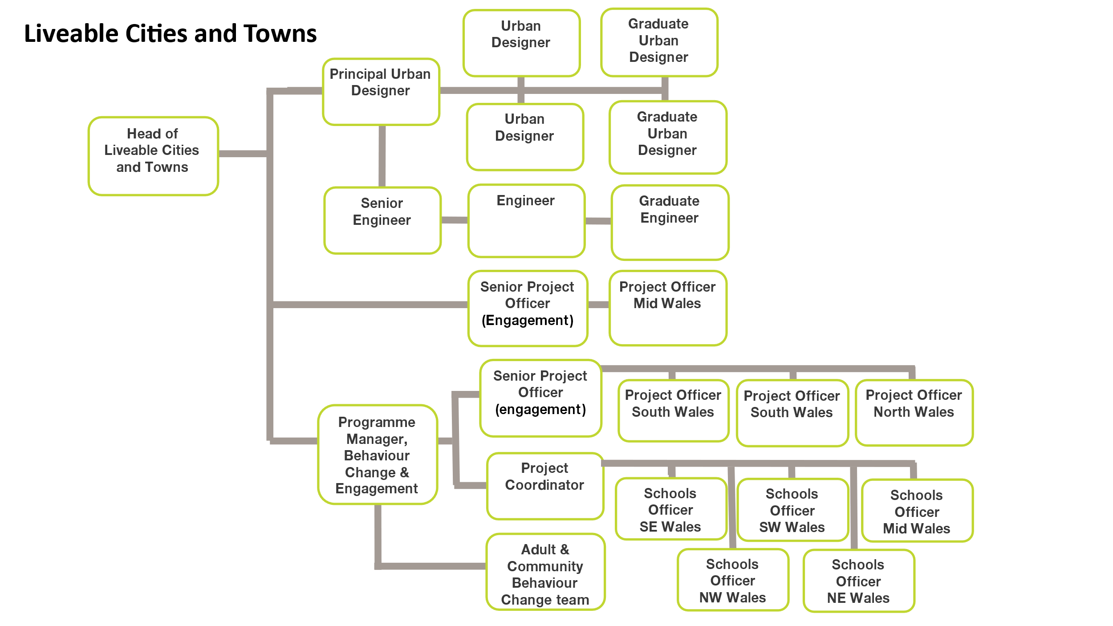

Job Description - About the Role

Overview
Working with up to 30 schools across Southeast Wales, you will plan and deliver a range of interactive, fun, and engaging activities and initiatives, that help to increase levels of active travel amongst pupils, families, school staff and the wider school community.

In this role, you will develop and maintain relationships with key organisations, engaging with people from different communities and backgrounds to help us ensure our work with schools is fully inclusive, reaching those who stand to benefit most from our support.

Responsibilities will include:
- To coordinate school involvement in the Active Journeys Programme in Southeast Wales. This will include guiding schools to progress through a structured process of behaviour change, upskilling school staff and providing information and practical activities to pupils and the wider school community.
- To ensure our approach and communications are respectful of other cultures, religions and beliefs, use inclusive language and include representative imagery.
- To deliver defined activities, active travel lessons, training and advocacy in a number of selected schools, including cycling & scooter skills.
- To deliver teacher and adult training events for participating schools.
- To liaise with local authority staff and Sustrans’ Network Development Manager to co-ordinate Safe Routes in Communities proposals and Active Travel Network Map development.
- To establish local partnerships, including local authority staff and other key stakeholders to maximise local ownership of active travel projects in schools.
- To monitor and report on project activity and conduct travel behaviour surveys.
- To work in partnership with the wider team in Wales to align activities and outcomes with Liveable Cities & Towns priorities.
- In conjunction with the Sustrans Cymru policy team, to provide press stories, case studies and help deliver events at schools to be attended by decision makers.
- To provide input and contribute to the production of progress reports and presentations for project partners including local authorities and Welsh Government.
- To recruit and support volunteers to assist with the running of the project and to provide legacy for the project.

We don’t expect anyone to be an expert in all these areas and as long as you meet the person specification we can train you in any gaps.

Person Specification
The following criteria sets out the method by which the skills, knowledge and experience will be assessed against. You should use the selected criteria as a guide to convey the evidence of your experience in these areas on your application form. Our website has a useful guide about how to make a great job application.

 | Application Form | Interview
Skills and Abilities
Ability to teach / train / instruct in an inclusive and accessible way. |  | ü
Excellent writing, communication and presentation skills | ü
Strong organisational and planning skills | ü
Well-developed interpersonal skills, with the ability to motivate and enthuse others – young & old |  | ü
IT literate with Microsoft Word, PowerPoint, Excel. | ü
Welsh language - oral and written fluency |  | ü
Specific experience required
Experience of leading group workshops and event planning for a range of audiences, including engaging with marginalised communities. | ü
Experience of education provision and working with children and young people | ü | ü
Experience of self-starting, independent project delivery | ü
Experience of delivering skills training | ü
Specific knowledge required
An understanding of the barriers to active travel for people from different backgrounds and with different abilities. |  | ü
Good understanding of school settings |  | ü
Basic understanding of effective behaviour change initiatives. | ü

This document does not form part of the contract of employment but does outline our expectations.
If we need to amend this document in the future we will consult with the post holder before doing so.

Everyone at Sustrans

Our values guide us in everything we do:
- Including everyone
- Having the courage to question
- Acting local, thinking big
- Getting things done, together
- Always learning.

- Sustrans has clear health and safety policies and it is essential that all our colleagues follow these. Very often our teams come into contact with young people through schools work or community engagement so it is everyone’s responsibility at Sustrans to comply with our Safeguarding policies.

- One of our key strategic goals is to be a charity “for everyone”, building a more diverse and inclusive Sustrans. We recognise there is much more we can do to bring together diverse life experiences and voices to enable us to understand, access and represent the communities we work in. more fully Everyone at Sustrans should support this goal and follow our Equality, Diversity and Inclusion policies and procedures.

- Sustrans asks that all our employees develop their skills, knowledge and experience through training and personal development activities. Sustrans will support you with clear objectives and a supportive management culture - our teams tell us that one of the great things about working for Sustrans is the learning and knowledge sharing opportunities.

- It is very important that our colleagues are happy and able to work with IT systems - we use Microsoft programmes and other databases every day (we will train you on our bespoke systems).

- It is also important that everyone at Sustrans supports and follows with the charity’s guidance on branding/key messages and contributes towards raising Sustrans’ profile.

- Everyone at Sustrans is required to work their contracted hours and record their time – if extra hours are worked then we can take time off in lieu.

- We ask that everyone in Sustrans helps us to develop new opportunities for funded work and builds excellent relationships with our delivery partners and stakeholders.

- Two of our values are we get things done, together and we’re always learning. Managers often require their teams to get involved in activities that are outside of their job descriptions as we feel this is one of the ways you can learn on the job, develop new skills, make new contacts and progress your career with Sustrans.

