For Everyone
  - Strategic Framework
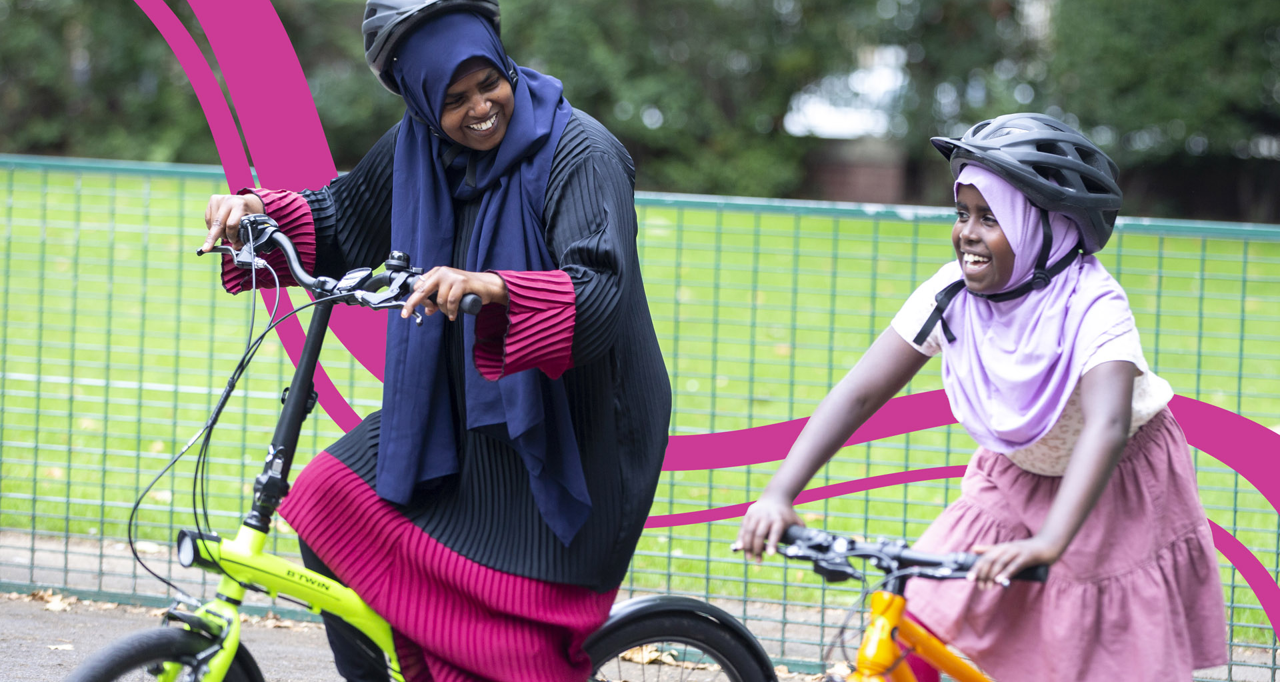
06 February 2024
To find out more, please contact: Tiffany Lam
Tiffany.lam@sustrans.org.uk
Photo credit: Jonathan Bewley
We work for and with communities, helping them come to life by walking, wheeling and cycling to create healthier places and happier lives for everyone. www.sustrans.org.uk
Registered charity no. 326550 (England and Wales)
SC039263 (Scotland).

Executive Summary
1
Document title over one line, maximum 15 words text text text text text
00 Month 2019
At Sustrans, our mission is to make it easier for everyone to walk, wheel and cycle. As the largest UK active travel charity, we can play a key role in making active travel more equitable, diverse and inclusive. Our ambition to be an organisation for everyone is reflected in our two external strategic priorities: Paths for Everyone and Liveable Cities and Towns for Everyone.
This For Everyone Strategic Framework is a living document that outlines our strategic approach to For Everyone internally and externally over the next five years. It presents a critical opportunity for us to demonstrate leadership by advancing equity, diversity and inclusion (EDI) in the UK transport sector.
There are three components of the strategic framework:
- Internal: Our approach to becoming a more diverse and inclusive organisation.
- External: Our approach to embedding EDI in our external work (delivery and campaigning).
- Enablers: Four enablers underpin both sides of the strategic framework to enable implementation:
- Leadership & accountability
- Engagement
- Monitoring, evaluation & learning
- Fundraising
The internal and external dimensions are structured around areas of focus, each with key outcomes. This is illustrated below in Tables 1 and 2.
The strategic framework has guided the business planning process between October 2023 and February 2024, as all directorates have prioritised one or two areas of focus and embedded actions to drive key outcomes in their 24/25 business plans. The strategic framework will evolve with and inform the wider Sustrans Strategy Review in 2024.
Table 1. Internal: Areas of focus and key outcomes
Area of focus  2  Document title over one line, maximum 10 words text text  00 Month 2019  3  Document title over one line, maximum 15 words text text text text text  00 Month 2019  4  Document title over one line, maximum 10 words text text  00 Month 2019  5  6  7 | Key outcomes
Employee lifecycle | - Increased diversity data collection and analysis.  Increased representation of women, disabled people and people of colour, particularly in senior leadership roles.  Increased feelings of inclusion, particularly among women, disabled people and people of colour.  Increased trust between senior leadership, HR and colleagues.  Increased accessibility and inclusion in recruitment process.
Leadership & Governance | - Improved senior leadership and oversight of For Everyone agenda.  Increased clarity and focus on For Everyone objectives and actions across the organisation.  Strengthened governance of EDI groups and colleague networks, including increased synergies between EDI groups, colleague networks and the wider organisation.
Learning & Development | - Enhanced and more strategic EDI training offer.  Increased understanding of EDI issues – both internal and external.  Improved accessibility of new Learning Management System (LMS).
Policies | - Increased consistency across all our policies, in terms of format, style and tone.  Improved EDI policies to reflect best practice and commitment to our colleagues.  Increased capacity for conducting Equality Impact Assessments of all our policies.
Culture | - Increased culture of accountability, including increased confidence and capability to have difficult conversations with and between colleagues.  - Increased culture of mutual respect that embraces diversity.  - Improved processes for raising concerns.  - Improved integration of EDI into day-to-day work and culture.
Communication | - More regular communication about the For Everyone agenda from senior leaders.  - Increased credibility and transparency in communications about For Everyone.  - Increased inclusivity and accessibility across our internal and external communications.

Table 2. External: Areas of focus and key outcomes
Area of focus  2  Document title over one line, maximum 10 words text text  00 Month 2019  3  Document title over one line, maximum 15 words text text text text text  00 Month 2019  4  Document title over one line, maximum 10 words text text  00 Month 2019  5  Document title over one line, maximum 15 words text text text text text  00 Month 2019  6  Document title over one line, maximum 10 words text text  00 Month 2019  7  Document title over one line, maximum 15 words text text text text text  00 Month 2019 | Key outcomes
Safety and Wellbeing | - Improved perceptions and experiences of safety, particularly for women, girls and LGBTQ+ people, on the National Cycle Network and in cities and towns across the UK.  Improved air quality, particularly in areas with the highest levels of traffic-related air pollution.  Healthier and safer streets that increase opportunities for outdoor activity by vulnerable communities.
Accessibility | - Improved accessibility of the National Cycle Network, particularly for disabled and neurodivergent people.  - Increased cultural accessibility of the National Cycle Network, particularly for communities of colour.  - Increased access to everyday services and amenities that help people to live well including jobs, education, shops, green space and public transport.  - More inclusive walking, wheeling and cycling routes and networks to make these journeys easy, safe and convenient.
Economic Inclusion | - Increased viability of active travel for people with low or no incomes.  - Increased visibility and prioritisation of journey purposes that are overlooked in transport planning (e.g. cycling as work, mobilities of care).  - Uptake of alternative transport appraisal method that factors in equity, public health and environmental goals.  - Increased integration of active travel into local, regional and national approaches to wider economic issues.

