Cynllun Ysgol Teithio Llesol | Active Travel School Plan

School
School Champion(s)
Where are we now?

What do we want to change?

Goals for academic year

1:

2:

3:

Actions  How to achieve your goals this year? |  | Completion date | Who is responsible? | Which goal impacted?
Autumn
Spring
Summer
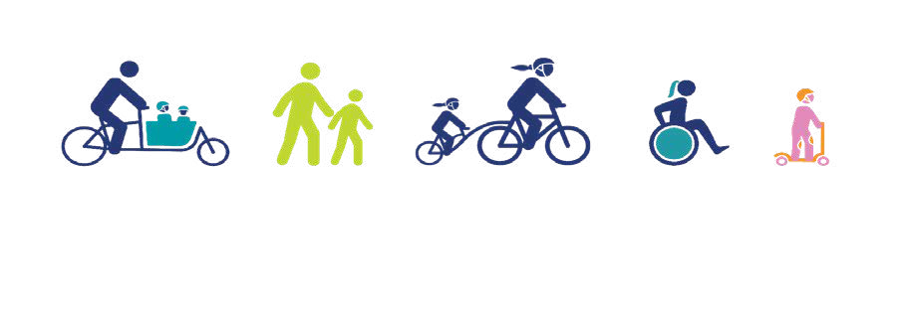
Date: Signed:

